**CHAPTER 1**

**INTRODUCTION**

**1.1.GENERAL**

The science of looking at the urine for diagnostic purposes, uroscopy, is as ancient as disease. Throughout history, urine, the first bodily fluid to be examined, has continuously and persistently provided medicine with an increasing body of knowledge about the workings of the inner body. For most of its history, uroscopy was a visual science; this focus peaked in the Middle Ages, when the vessel used to examine urine, the matula, became a symbol of the medical profession. Over time, the practice of uroscopy spread into the hands of quacks and apothecaries, who prescribed and sold their potions by merely looking at the urine. The consequent reformation measures of the 16th and 17th centuries coincided with the first attempts at analysing the contents of urine. As a result, many of the chemical components now reported in metabolic profiles were first analysed and identified in urine during the first half of the 18th century. In the process, what started as a science that bordered on divination laid the foundations of chemical analysis and spawned the disciplines of urology, endocrinology, and, after the use of urine in clearance studies, nephrology. Medical testing kits are an important tool used by healthcare professionals to diagnose and monitor various medical conditions. These kits typically contain all the necessary materials and instructions needed to perform a particular test, and are designed to be easy to use and accurate.

There are many different types of medical testing kits available, including kits for blood tests, urine tests, and tests for infectious diseases such as the flu or HIV. Some kits are designed for use in a laboratory setting, while others are intended for use at home or in the field. One of the main advantages of medical testing kits is their convenience. With a kit, a healthcare professional can easily perform a test without having to gather all the necessary materials separately. This saves time and helps to ensure that the test is performed correctly. The analytical methods and remarkable achievements of each of these disciplines have increased the value of examining urine. A renaissance of this oldest diagnostic tool of medicine is now under way in the proteomic profiling and detection of biomarkers in the urine, an approach which promises to further extend the merits of the unbroken tradition of looking at the urine.

**1.2. INTRODUCTION TO URINE ANALYSIS**

A urinalysis is a common test that can assess many different aspects of your health with a urine sample. Healthcare providers often use urinalysis tests to screen for or monitor certain health conditions and to diagnose urinary tract infections. A urinalysis (also known as a urine test) is a test that examines the visual, chemical and microscopic aspects of your urine (pee). It can include a variety of tests that detect and measure various compounds that pass through your urine using a single sample of urine.

Healthcare providers often use urinalysis to screen for or monitor certain common health conditions, such as [liver disease](https://my.clevelandclinic.org/health/diseases/17179-liver-disease), [kidney disease](https://my.clevelandclinic.org/health/diseases/15096-kidney-disease-chronic-kidney-disease) and [diabetes](https://my.clevelandclinic.org/health/diseases/7104-diabetes-mellitus-an-overview), and to diagnose [urinary tract infections](https://my.clevelandclinic.org/health/diseases/9135-urinary-tract-infections) (UTIs).

While several different aspects of your health can be tested with a urine sample, your healthcare provider will choose which tests to order under a urinalysis depending on your symptoms and situation.

Your healthcare provider can include several different tests in a urinalysis. Depending on your symptoms, existing health conditions, and/or situation, your provider will choose which urine tests to order under a urinalysis.

In general, a healthcare provider or laboratory technician can examine a urinalysis urine sample for the following broad aspects:

* Colour and appearance.
* Chemical findings.
* Microscopic findings.

For most urinalysis tests, a healthcare provider examines how the urine sample looks to the “naked eye.” They check if it’s clear or cloudy and if it’s pale, dark yellow or another colour.

Normal urine colour is usually some shade of yellow and can range from colourless or pale yellow to deep amber, depending on how concentrated or diluted (watery) your urine is.

Many things can affect the colour of your urine, including certain medications and supplements and certain foods you eat, such as beets. However, an unusual urine colour can also be a sign of disease. For example, red-coloured urine can happen when blood is present in your urine and can be an indicator of disease or damage to a part of your [urinary system](https://my.clevelandclinic.org/health/articles/21197-urinary-system).

Cloudy urine doesn’t always indicate unhealthy urine. For example, sperm and skin cells are harmless and could make your urine appear cloudy. Other substances that can make your urine cloudy, such as red blood cells, white blood cells and bacteria, may indicate several different medical conditions, including:

* [Dehydration](https://my.clevelandclinic.org/health/treatments/9013-dehydration).
* Urinary tract infection (UTI).
* [Sexually transmitted infections](https://my.clevelandclinic.org/health/diseases/9138-sexually-transmitted-diseases--infections-stds--stis) (STIs).
* [Kidney stones](https://my.clevelandclinic.org/health/diseases/15604-kidney-stones).
* Diabetes.

**1.3. RATIONALS OF URINE ANALYSIS**

Healthcare providers order urinalysis tests for several reasons since a urine sample can provide many insights into your health. Your provider may order a urinalysis for you for one or more of the following reasons:

* As part of your routine medical exam to screen for early signs of certain health conditions.
* If you’re experiencing and signs and symptoms of certain health conditions, such as diabetes or kidney disease.
* To monitor certain health conditions you're receiving treatment for, such as diabetes or kidney disease.
* To diagnose a urinary tract infection (UTI).
* If you’ve been admitted to a hospital.
* As a preparatory checkup for surgery.

Urinalysis tests are very common. They’re a simple and non-invasive way to check several different aspects of your health. The Healthcare professionals also order the urine analysis

* To check for the presence of proteins.
* To asses acid-base balance.
* To check for the presence of drugs.
* To screen the genetic disorder.
* To check for the presence of blood and glucose.

**1.4.URINE**

Urine is a waste product of [metabolism](https://www.biologyonline.com/dictionary/metabolism) and is formed in the kidneys to be excreted normally through [urination](https://www.biologyonline.com/dictionary/urination) or micturition. In mammals, including humans, urine is in a liquid form whereas in birds and reptiles, it is solid or semisolid. The biological system responsible for the production of urine is the [urinary system](https://www.biologyonline.com/dictionary/urinary-system). It is comprised of [kidney](https://www.biologyonline.com/dictionary/kidney)s, [ureter](https://www.biologyonline.com/dictionary/ureter)s, urinary bladder, and [urethra](https://www.biologyonline.com/dictionary/urethra). The processes that lead to the formation of urine are filtration, reabsorption, and tubular secretion. From the kidneys, the urine passes through the ureter and stored in the urinary bladder. When it is to be excreted from the body, the urine passes through the urethra.  
Human urine is chiefly comprised of [water](https://www.biologyonline.com/dictionary/water) (91 to 96 %). Other components are inorganic salts, [protein](https://www.biologyonline.com/dictionary/protein)s, [hormone](https://www.biologyonline.com/dictionary/hormone)s, and other [metabolite](https://www.biologyonline.com/dictionary/metabolite)s. It has a specific gravity ranging from 1.003–1.035. The pH ranges from 5.5 to 7. It is typically slightly transparent to amber in colour. Colourless urine may indicate over-hydration whereas dark yellow urine may indicate [dehydration](https://www.biologyonline.com/dictionary/dehydration). Hematuria (bloody urine) and melanuria (a black or dark-coloured urine) are possible symptoms of certain underlying medical conditions.

Urine produced by an adult healthy person is, on average, is about 1.4 L in a day. The amount of urine excreted depends on the health and medical condition of a person. Excessive urine production (i.e. >2.5 L/day) is referred to as polyuria. In contrast, the condition wherein less than 100mL urine is produced per day is referred to as anuria.

The exact composition of urine varies depending on various factors such as the body's hydration status, the types and amounts of substances that are being metabolized, and the individual's diet and lifestyle. Water: Urine is composed primarily of water, which is essential for maintaining the body's hydration status and for regulating the concentration of electrolytes and other substances in the body. Waste products: Urine also contains a variety of waste products that are produced as a result of the body's metabolic processes. These include urea, creatinine, and a range of other nitrogenous compounds, as well as various hormones, drugs, and other substances that are not needed by the body. Electrolytes: Urine contains a variety of electrolytes, including sodium, potassium. chloride, and bicarbonate, which are important for maintaining the body's acid-base balance and for regulating various bodily functions.

In addition to these components, urine may also contain small amounts of other substances. such as proteins, glucose, and ketones, depending on the individual's health and dietary habits. By analysing the various components of urine, healthcare professionals can gain valuable insights into an individual's health and metabolism.

**1.5.BILE**

Bile is derived from the Latin word “Bilis” which is maybe a dark-green to yellowish-brown fluid produced by the liver of most [vertebrates](https://www.vedantu.com/biology/vertebrates) that helps in the digestion of [lipids](https://www.vedantu.com/biology/lipids) within the intestine. In humans, bile is secreted from the liver continuously and is stored and concentrated within the gallbladder. After the consumption of food, this stored bile is discharged into the duodenum to perform the process of digestion. The composition of hepatic bile is as follows,

* 97–98% of water
* 0.7% bile salts
* 0.2% bilirubin
* 0.51% fats such as cholesterol, fatty acids, and lecithin
* 200 mEq/l of inorganic salts

The two main [pigments](https://www.vedantu.com/biology/pigments) of bile are bilirubin, which is orange-yellow, and its oxidized form is biliverdin, which is green in colour. When these two pigments are mixed, they are liable for the brown colour of feces. About 400 to 800mL of bile is produced per day in the adult citizenry.

The liver secretes bile or gall that acts as a surfactant to some extent, that helps to emulsify the lipids in food. Bile salt consists of anions that are hydrophilic on one side and hydrophobic on the other side. Consequently, they have a tendency to aggregate around droplets of lipids such as triglycerides and phospholipids to make micelles. In the micelles, the hydrophobic sides are faced inwards to the fat, and the hydrophilic sides facing outwards. The hydrophilic sides of the micelles are charged and these charged micelles sides are required to prevent the fat droplets from re-aggregating into larger fat particles that are coated with bile. In the case of humans, the micelles that are present in the duodenum have a diameter of around 1–50 μm.

The dispersion of food fat into micelles provides a greatly increased area for the action of the enzyme pancreatic lipase, which actually digests the triglycerides, and is in a position to reach the fatty core through gaps that are present in between the bile salts. A triglyceride is formed into two fatty acids and a monoglyceride is absorbed by the villi that are present on the walls of the intestine. After being transferred across the intestinal [membrane](https://www.vedantu.com/biology/membrane), the fatty acids reform into triglycerides by the process called re-esterification, before being absorbed into the systema lymphatica through lacteals. In the absence of bile salts, most of the lipids that are obtained from food would be undigested and excreted in feces.

The liver, the place where is bile released, increases the absorption of fats, it's a crucial part of the absorption of fat-soluble substances, like vitamins A, D, E, and K. A by product of red blood [cells](https://www.vedantu.com/biology/cells) that are recycled by the liver produces bilirubin, along with the digestive function it acts as a route for [excretion](https://www.vedantu.com/biology/excretion) of the bilirubin. Bilirubin derives from hemoglobin by glucuronidation.

The fluid that is made and released by the liver is considered bile. The main and important function of the bile is to help in the digestion of fats into fatty acids. In the absence of bile, the consumed fats or the vitamins that are required to dissolve the fat get accumulated in the colon of the intestine where it causes several complications.

The liver is a vital organ that plays a central role in many important bodily functions. Some of the key functions of the liver include:

* Storage: The liver stores a variety of important substances, including glucose (as glycogen), iron, and certain vitamins and minerals.
* Synthesis: The liver is also responsible for the synthesis of a variety of Important substances, including bile, cholesterol, and various hormones and enzymes. health and function of the liver. Regenerate response.
* Detoxification: The liver plays a crucial role in the detoxification of the body, removing toxins and other harmful substances from the blood. It does this through a variety of enzymes and other biochemical processes.
* Metabolism: The liver is responsible for the metabolism of a wide range of substances, including carbohydrates, proteins, and fats. It converts these substances into energy, stores them for later use, or excretes them from the body as needed.

To perform these functions, the liver is made up of a variety of specialized cells and tissues, Including hepatocytes (liver cells), Kupffer cells (immune cells), and sinusoidal endothelial cells (blood vessels). Together, these cells and tissues work together to maintain the overall

**CHAPTER 2**

**LITERATURE SURVEY**

Jaundice global estimated infection with hepatitis about 1.5 billion people’s per year. Nearly half of (49%) had no symptoms prior to analysis. One in five (21%) sufferers had been recognized in health center almost one-third (32%) had been diagnosed during other tests. 50% had been recognized after they already had symptoms and one out of 5 of these have been recognized during emergency situations. In 2019 WHO estimated 2.90 lack people were died in hepatitis. Around 62% of peoples had been treated with hepatitis. Another 38%of people they don’t know how to test the disease. 59% of people did now not experience that they were given sufficient facts at prognosis almost 4 out of ten (39%) sufferers waited for greater than six months for experts advice.

A quarter (24%) of patients have been extremely glad with their care and one in 10 (10%) people had been extraordinarily unhappy. Nine out of ten humans attempted to discover more after leaving their health center appointment with over 90%. The study of population comprised 74% of women about 90% where treated in hepatitis. Where treatment experienced. The major of hepatitis where completer without side effects. The common of alcoholic hepatitis is yellowing skin and whites of eyes. In 87% of cases diagnosis was conformed at operation or pathological examinations, awareness of pre-diagnosis as been lately decreased in numbers. One in five was wrongly diagnosed as viral hepatitis.

Viral hepatitis is a major public health problem in India (SINGH et al., 1997). It is caused by at least 6, and possible more, distinct viral agents including hepatitis A to E virus and recently discovered hepatitis G virus (HGV). All of them circulate in India and usually cause clinically indistinguishable illnesses. Besides acute infection, hepatitis B virus (HBV) has the ability to cause persistent infection (chronic carriers), the sequelae of which include chronic active hepatitis, liver cirrhosis and primary hepatocellular carcinoma (WHO, 1996). It is estimated that about 25% of individuals who become persistent carriers of HBV will eventually die of these sequelae (WHO, 1996). Available data indicate that about 3-5% of the population may be persistent carriers of this virus in India (authors’ unpublished review of data on HBsAg prevalence in India). When hepatitis B chronic carrier rates are \* 2%, the most effective strategy is the incorporation of the vaccine into the routine infant immunization schedule (WHO. 1996). More than 100 countries have already integrated hepatitis B vaccine into their routine immunization programme (WHO, 1999). In the last months of 1996, the Government of National Capital Territory of Delhi initiated a pilot project in the eastern part of Delhi to find the operational feasibility of integrating hepatitis B vaccine in the routine immunization programme. Before implementing the project, it was felt necessary to know the community perceptions of jaundice/viral hepatitis and hepatitis B vaccine. The present study was undertaken for this purpose.

With around 9.4 million population (1991 census) living in an area of 1483 km’, Delhi, the capital of India, has one of the highest population densities in the world (6352 per km’). The city is continuously getting more and more crowded at a constant decennial growth rate of around 50% without keeping pace with improvement in hygiene and sanitation and safe water-supply. A sizable population lives in slums and resettlement and unauthorized colonies, which lack in sewerage and adequate piped water. There are 827 females per 1000 males. Literacy it& are 82% and 67% in males and females, respectively, according to the 199 1 census.

All types of viral hepatitis occur in Delhi. Hepatitis A affects all. Mostly in early childhood or adulthood (National Institute of Communicable Diseases, unpublished data). The prevalence of hepatitis B chronic carriers among antenatal mothers (NAYAK et al., 1987) and voluntary blood donors (IRSHAD et al., 1994) in Delhi has been estimated as 3.7% (n = 8575) and 2.6% (n = 20435), respectively. There is evidence that the pool of chronic carriers is built up during childhood (NAYAK et al., 1987; TANDON et al., 1991). About 1.5% of healthy adults are positive for hepatitis C virus antibodies (IRSHAD et al., 1995). Hepatitis E accounts for a substantial proportion of acute sporadic cases and all the outbreaks of viral hepatitis, which are not uncommon in Delhi. These outbreaks invariably occur due to contamination of the piped water-supply and affect mostly young adults, especially males. The study was carried out in the eastern part of the city (population 2.1 million, 199 1 census) in the 3rd week of November 1996.

Medical testing kits are devices or systems that are used to diagnose, monitor, or treat medical conditions. They can be used to detect the presence of a particular disease or condition, to measure the severity of a condition, or to monitor the effectiveness of a treatment. Medical testing kits can be used in a variety of settings, including hospitals. clinics, laboratories, and even at home.

**CHAPTER 3**

**CONCEPT OF EXISTING MODEL**

Bilirubin is a yellow pigment that’s in everyone’s blood and stool. A bilirubin blood test determines the levels of bilirubin in the body. Sometimes the liver can’t process the bilirubin in the body. This can be due to an excess of bilirubin, an obstruction, or inflammation of the liver. When your body has too much bilirubin, your skin and the whites of your eyes will start to yellow. This condition is called [jaundice](https://www.healthline.com/health/jaundice-yellow-skin). A bilirubin test will help determine if you have any of these conditions. Bilirubin is made in the body when the hemoglobin protein in old red blood cells is broken down. The breakdown of old cells is a normal, healthy process.

After circulating in your blood, bilirubin then travels to your liver. In the [liver](https://www.healthline.com/human-body-maps/liver), bilirubin is processed, mixed into bile, and then excreted into the [bile ducts](https://www.healthline.com/human-body-maps/common-bile-duct) and stored in your [gallbladder](https://www.healthline.com/human-body-maps/gallbladder). Eventually, the bile is released into the [small intestine](https://www.healthline.com/human-body-maps/small-intestine) to help digest fats. It’s ultimately excreted within your stool. Bilirubin attached by the liver to glucuronic acid, a glucose-derived acid, is called direct, or conjugated, bilirubin. Bilirubin not attached to glucuronic acid is called indirect, or unconjugated, bilirubin. All the bilirubin in your blood together is called total bilirubin. A comprehensive bilirubin blood test will get an accurate count of all three bilirubin levels in your blood: direct, indirect, and total. In both adults and children, symptoms related to high bilirubin can involve jaundice, a yellowing of the skin or eyes, [fatigue](https://www.healthline.com/symptom/fatigue), [itchy skin](https://www.healthline.com/health/itching), [dark urine](https://www.healthline.com/symptom/dark-urine), and low appetite.

If bilirubin isn’t being attached to the glucose-derived acid (conjugated) in the liver or isn’t being adequately removed from the blood, it can mean that there is damage to your liver. Testing for bilirubin in the blood is therefore a good way of testing for liver damage. Mild [jaundice in new born](https://www.healthline.com/health/newborn-jaundice) can either be due to normal changes in the metabolism of bilirubin, or it can be the first sign of a medical problem. If the level at birth is too high, an infant’s blood may be tested several times in the first few days of their life to monitor liver function. Jaundice in a new born can be very serious and life-threatening if left untreated.

Another reason for high bilirubin levels could be that more red blood cells are being destroyed than normal. This is called hemolysis. Sometimes bilirubin is measured as part of a “panel” of tests. Often, the liver is evaluated with a group of tests that also include:

* [alanine transaminase](https://www.healthline.com/health/alt)
* [aspartate aminotransferase](https://www.healthline.com/health/ast)
* [alkaline phosphatase](https://www.healthline.com/health/alp)
* [albumin](https://www.healthline.com/health/albumin-serum)
* [total protein](https://www.healthline.com/health/total-protein)

A small amount of your blood is needed to perform this test. The blood sample is obtained through ventricular puncture: A needle is inserted into a vein through the skin in your arm or hand, and a small amount of blood is collected in a test tube.

For this test, you will need to not eat or drink anything other than water for four hours before you have the test performed. You can drink your usual amount of water before going to the laboratory or collection site. You may have to stop taking certain medications before the test is performed, but only if your doctor tells you to do so. Examples of drugs that can affect bilirubin levels include antibiotics like penicillin G, sedatives like phenobarbital, diuretics like [furosemide](https://www.healthline.com/health/furosemide-oral-tablet#highlights1) (Lasix), and asthma medications like [theophylline](https://www.healthline.com/health/theophylline-oral-tablet).

There are many other drugs that can influence bilirubin levels. Talk to your doctor before your test to see if you should stop or continue taking medication. When the blood is collected, you may briefly feel moderate pain or a mild pinching sensation. After the needle is taken out, you may feel a throbbing sensation. You’ll be instructed to apply pressure to the site where the needle entered your skin. A bandage will be placed over the site. Keep this bandage on for at least 10 to 20 minutes. You should avoid using that arm for heavy lifting for the rest of the day. There are some very rare risks to taking a blood sample:

* Light headedness or fainting
* Hematoma, a bruise where blood accumulates under the skin
* Infection, usually prevented by the skin being cleaned before the needle is inserted
* Excessive bleeding, or bleeding for a long period afterward, which may indicate a more serious bleeding condition and should be reported to your doctor
* In an older child or adult, normal values of direct bilirubin are from 0–0.4 milligrams per deciliter (mg/dL). Normal values of total bilirubin are from 0.3–1.0 mg/dL.
* The indirect bilirubin level in the bloodstream is the total bilirubin minus the direct bilirubin levels in the bloodstream. Additionally, normal reference ranges may vary from lab to lab.
* In a new born, higher bilirubin is normal due to the stress of birth. Normal indirect bilirubin would be under 5.2 mg/dL within the first 24 hours of birth. But many new born have some kind of jaundice and bilirubin levels that rise above 5 mg/dL within the first few days after birth.

Your doctor may want to perform further blood tests or an [ultrasound](https://www.healthline.com/health/ultrasound) if high levels of bilirubin are detected in your blood. In an adult, high bilirubin may be due to problems with the liver, bile ducts, or gallbladder. Examples include: Liver diseases like [hepatitis](https://www.healthline.com/health/hepatitis), [gilbert’s syndrome](https://www.healthline.com/health/gilberts-syndrome), a genetic disease [cirrhosis](https://www.healthline.com/health/cirrhosis), which is scarring of the liver biliary stricture, where part of the bile duct is too narrow to allow fluid to pass [cancer](https://www.healthline.com/health/cancer) of the [gallbladder](https://www.healthline.com/health/bile-duct-cancer) or [pancreas](https://www.healthline.com/health/pancreatic-cancer) [gallstones](https://www.healthline.com/health/gallstones) drug toxicity.

High bilirubin may also be due to problems in the blood instead of problems in the liver. Blood cells breaking down too fast can be caused by:

* [Hemolytic anemia](https://www.healthline.com/health/hemolytic-anemia): This occurs when too many blood cells are being destroyed from an autoimmune disease, genetic defect, drug toxicity, or infection, and the liver is unable to metabolize the amount of indirect bilirubin in the body.
* [Transfusion reaction](https://www.healthline.com/health/transfusion-reaction-hemolytic): This occurs when your immune system attacks blood that was given to you through a transfusion.
* If your blood tests show abnormally high levels of bilirubin, your doctor may order more tests to determine the underlying cause.
* Once your doctor has determined a cause of high bilirubin levels, you may need to take more bilirubin blood tests to monitor the effectiveness of your treatment.
* If your doctor thinks your liver or gallbladder might not be functioning properly, they may order imaging tests to ensure there are no structural abnormalities.

**CHAPTER 4**

**PROPOSED MODEL OF DIAGNOSTIC DEVICE**

Health monitoring plays a major role in medical industries. In recent years, lifestyle related illness has become more pronounced and demand for technology that enables easy and quick checking of diseases is increasing. Urine analysis is a very promising field of research work having great potential for diagnosis of diseases in non-invasive way for analyzing the bilirubin concentrations in excreted human urine. Approximately 1.5 billion people worldwide are said to be affected by jaundice along with hepatitis.

By monitoring the excreted human urine we will predict few diseases such as jaundice and hepatitis. In our system we monitor the excreted human urine and checks the person is affected by any of that disease. At the same time of instance we can able to see the value real time using IOT module. This system consists of Light Dependent Resister ,Light Emitting Diode, NODE MCU and PIC microcontroller. Basically bilirubin level is used to check whether patient affected by jaundice and hepatitis or not. The normal healthy human's bilirubin level is 1.2 milligrams per deciliter (mg/dL) for adults and usually 1 mg/dL for those under 18. Jaundice and hepatitis patient bilirubin level are greater than 2.5 to 3 mg per dL (42.8 to 51.3 μ/ L) in conjunction with a clinical picture of yellow skin and sclera.

Light Dependent Resistor are extensively used in urine analysis. The small size, ease of operation, inexpensiveness, and low maintenance make Light dependent Resistor one of the best candidates for Urine analysis. Standalone chemical Biomarkers of bilirubin have tried to co-relate jaundice and hepatitis with a targeted excreted bilirubin in urine. We use absorbance of bilirubin in urine to calculate the concentration of bilirubin in urine using a voltage divider circuit. The level of absorbance of bilirubin in human urine varies based on the source of wavelength of absorption. We use a source with a wavelength of 450nm(blue), 620nm(Yellowish-orange) and 700nm(red). The level of bilirubin absorbance in normal human urine is less then 1 AU/cm for 450nm and 620nm source and less then 0.6AU/cm for 700nm source. The level of absorbance of bilirubin in urine for jaundice patient ranges from 1-1.35AU/cm for 450nm and 620nm source and ranges from 0.6-1AU/cm for 700nm source. . The level of absorbance of bilirubin in urine for hepatitis patient is above 1.35AU/cm for 450nm and 620nm source and ranges above 1AU/cm for 700nm source.

ARKRAY, Inc. is developing a pain-free bilirubin detector based on excreted human urine bilirubin detection. The device comprises Light dependent resistor for each sources of wavelength that can react based on the amount of absorbance of bilirubin in urine. However, the relevance of bilirubin as the sole biomarker for jaundice and hepatitis-monitoring is uncertain, as most single measurement studies report no correlation between excreted bilirubin in urine and blood, whereas continuous monitoring studies report both positive and negative correlations. The fact that excreted bilirubin in urine is an indicator of the physiological and metabolic processes of the human body consolidates the relevance of urine analysis for health and disease diagnostics. The amount of concentration of conjugated bilirubin in urine and blood are corelated with the urine and blood samples from the patients.

**PIC MICRO-CONTROLLER**

SAMPLE

**LED 1**

**LDR 1**

**LED2**

**LDR 2**

**LED3**

LDR 3

**APPLICATION**

**IOT MODULE**

**FIG 4.1. BLOCK DIAGRAM OF IMPLEMENTED MODEL**

Jaundice and Hepatitis monitoring through the excreted urine analysis is indeed complex, because it is an indirect methodology that relies on monitoring the human body's metabolic processes through the associated bilirubin biomarkers instead of direct blood sampling. Besides the recently explored biofluids, urine excreta can also assist in non-invasive bilirubin monitoring as it has rapid and stable bilirubin exchange with liver. There happens to be an increase in bilirubin concentration of urine in Gilbert’s syndrome. Bilirubin sensing through urine could be a breakthrough in non-invasive monitoring, but a few concerns, including bilirubin dilution, sample stability, and subject variability, need to be alleviated. A crucial step in urine analysis is urine sampling. Excreted urine broadly consists of blood and dark colored pus containing phases. Colourless urine may indicate over-hydration whereas dark yellow urine may indicate [dehydration](https://www.biologyonline.com/dictionary/dehydration). Hematuria (bloody urine) and melanuria (a black or dark-coloured urine) are possible symptoms of certain underlying medical conditions.

Therefore, the target urine biomarkers govern the choice of selecting the urine for sampling. For example, gonadotropin(hCG), often used for clinical characterization of pregnancy, originates from the female ovaries. Hence the results on urine analysis varies based on the sample of urine being tested.

**CHAPTER 5**

**IMPLEMENTATION OF PROPOSED DEVICE**

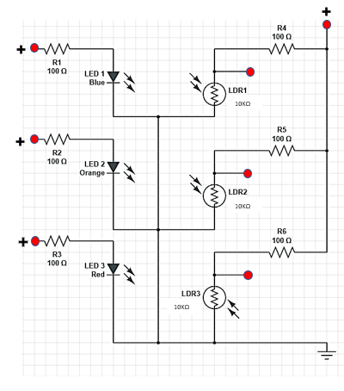 Our proposed diagnostic device consist of Light Dependent Resistor which enables us to calculate the concentration of bilirubin in urine excreted from human. By monitoring excreted urine bilirubin concentration using absorbance helps as to credit the diseases such as jaundice, hepatitis, liver cirrhosis, etc., by quantitative analysis of excreted bilirubin in human urine interms of AU/cm, moles/litres, milligrams/decilitres, etc., it is important that blood consist of two types of bilirubin namely conjugated(direct) and unconjugated(indirect) bilirubin. Indirect bilirubin is formed by the breakdown of

**FIG 5.1. VOLTAGE DIVIDER CIRCUIT**

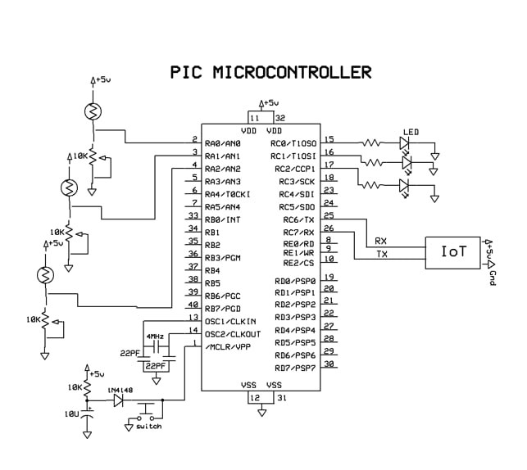hemoglobin in the red blood cells. The liver converts this bilirubin into direct bilirubin, which can then be released into the intestine by the gallbladder for elimination. Total bilirubin levels are therefore indicative of both the destruction of red blood cells and the proper functioning of the liver, gallbladder, and bile ducts. Conjugation of bilirubin to the water soluble form involves the disruption of the hydrogen bonds, an essential process for its elimination by the liver and kidney. This is achieved by glucuronic acid conjugation of the propionic acid side chains of bilirubin. Conjugated bilirubin and other substances destined to be excreted in bile are actively transported across the bile

**FIG 5.2 SCHEMATIC DIAGRAM OF IMPLEMENTED MODEL**

canalicular membrane of the hepatocyte. The concentration gradient is very high and can reach 1:1000.

Unconjugated bilirubin may escape the hepatocyte cytosol into the plasma where it binds to albumin and gets transported around the body. However, only conjugated bilirubin can enter the bile. The conjugated bilirubin is then actively secreted into canalicular bile and drains into the small intestine and excreted as urine. By using three variables sources of wavelength(450nm,620nm,700nm) the absorbance of bilirubin in urine is analysed for quantitative calculation of bilirubin concentration in human urine using the voltage divider circuit.

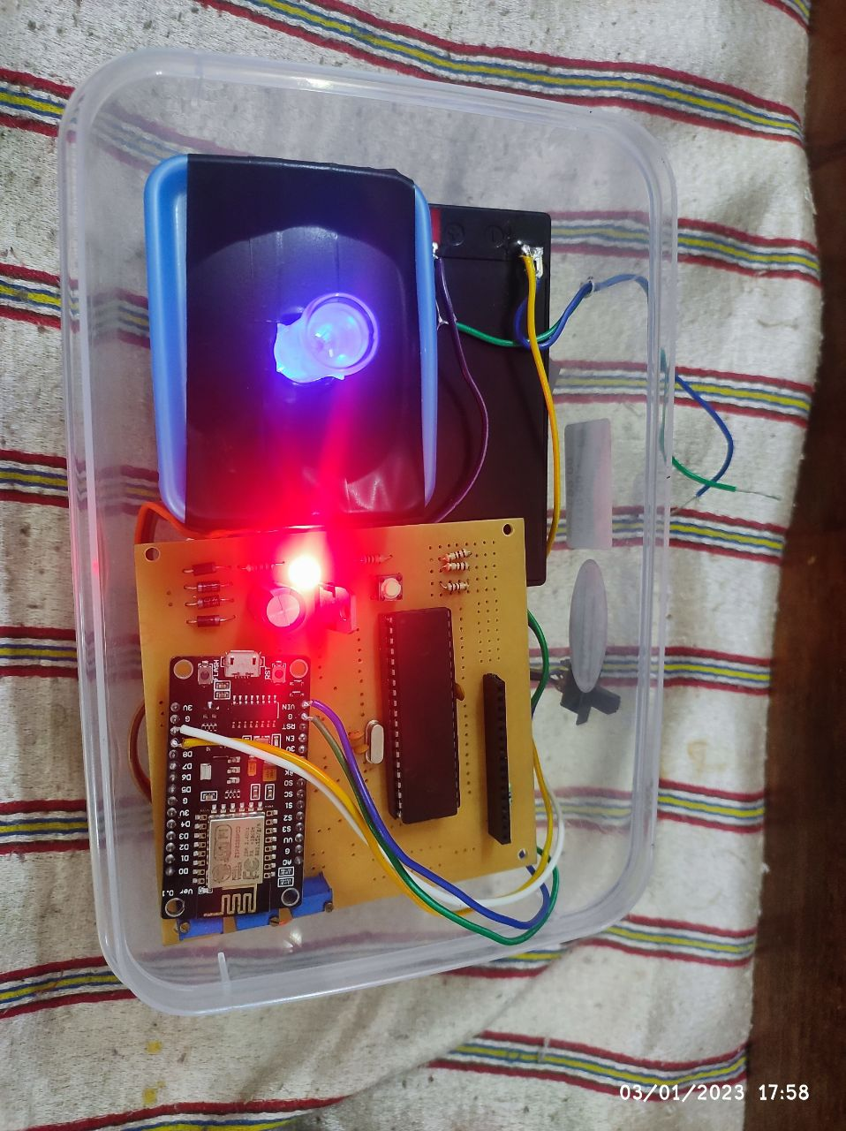The voltage divider circuit as in the figure 5.1 helps to analyse the bilirubin absorbance in urine and response with the variation in voltage in Light Dependent Resistor which changes according to the concentration of bilirubin in urine. This variation in voltage is given as a input to the PIC microcontroller to analyse the absorbance and calculate the concentration of bilirubin. The bilirubin concentration is compared with the given data and the analysation of pathogenic output is relayed to the IOT module. The IOT module displays the human metabolic condition either jaundice or hepatitis based on the calculation of bilirubin concentration using bilirubin

**FIG 5.3 PROTOTYPE IMPLEMENTATION**

absorbance from excreted human urine.

The Device consists of a set of seven discrete elements. These elements are light emitting diodes (LEDs) aligned opposite to light-dependent resistors (LDRs) and IOT device. After the sample absorbs light coming from the LED, the LDR senses the change in light intensity, which is expressed as a change in the output voltage from a voltage divider working at constant input voltage. Therefore, when the equation of a voltage divider is used, it is possible to quantify the absorbance. The schematic diagram of the electronic circuit designed for the device as shown in Figure. An IOT device is used to decide on the colour of the LED to be used: blue, orange, or red. To achieve this, the LED terminal should be connected to the positive terminal of IOT (Vcc in the diagram). The source of voltage or power source is also connected to a resistor (100 Ω) and a LDR in series. Notice that there is a LDR for each LED and that they are aligned one opposite to each other. Between the 100 Ω resistor and the LDR, a connection is placed to obtain a voltage divider circuit. Then it is connected to the positive relative connector meanwhile the negative relative connector is connected to the ground terminal GND. All components are housed on a closed setup, which gives a stable position for the cuvette. To select a LED and perform the measurements, IOT runs the program to select each LED’s one by one and collects the voltage output from them. The collected information are used to calculate the absorbance by using the formula fed into the program and analyse them to check the bilirubin concentration in the urine. A 9 V DC battery is used as a Power Source, but we have observed that batteries discharge after only three or four experiments, drifting the voltage during an experiment and hampering good results. In this method we make use normal and abnormal persons. First of all we want to collect the fresh urine sample from that persons. Some prescription drugs can cause a false positive, or a higher-than-normal reading of bilirubin in your body. Some false positives results indicates high bilirubin level that aren't necessarily associated with jaundice , hepatitis or other liver disease. If the person takes

following drugs the results will be affected and they are categorized under 'Out of Constraint' condition. The following drugs are :

1. diuretics

2. birth control pills

3. steroids

4. barbiturates and sulfonamides.

**CHAPTER 6**

**HARDWARE DESCRIPTION**

**6.1. LIGHT DEPENDENT RESISTOR**

**6.1.1.INTRODUCTION**

Majority of street lights, outdoor lights, and a number of indoor home appliances are typically operated and maintained manually in many occasions. This is not only risky, however additionally it leads to wastage of power with the negligence of personnel or uncommon circumstances in controlling these electrical appliances ON and OFF. Hence, we can utilize the light sensor circuit for automatic switch OFF the loads based on daylight’s intensity by employing a light sensor. This article discusses in brief about what is a light dependent resistor, how to make a light dependent resistor circuit and its applications.

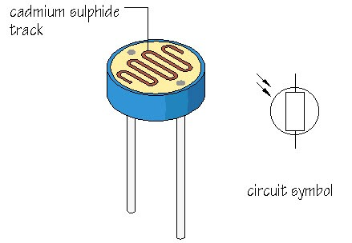

**FIG 6.1 LDR CIRCUIT DIAGRAM**

An LDR or [light dependent resistor is also known as photo resistor](http://en.wikipedia.org/wiki/Photoresistor), photocell, photoconductor. It is a one type of resistor whose resistance varies depending on the amount of light falling on its surface. When the light falls on the resistor, then the resistance changes. These resistors are often used in many circuits where it is required to sense the presence of light. These resistors have a variety of functions and resistance. For instance, when the LDR is in darkness, then it can be used to turn ON a light or to turn OFF a light when it is in the light. A typical light dependent resistor has a resistance in the darkness of 1MOhm, and in the brightness a resistance of a couple of KOhm

**6.1.2 CONSTRUCTION**

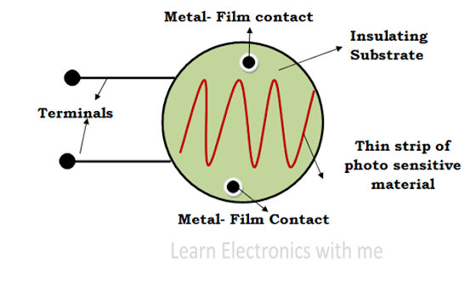

**FIG 6.2 CONSTRUCTION OF LDR**

The LDR is constructed by placing a thin zigzag shaped strip of photosensitive device upon the insulating material. The light sensitive materials used in LDR are Cadmium Sulphide (Cds), Cadmium Selenide (CdSe) or lead Sulphide (Pbs). The insulating material used in LDR is ceramic. The metal films are connected with the terminal leads. The whole structure is placed inside a plastic or resin case to have direct exposure to the sunlight. When there is no light the resistance is very high in Mega Ohms. When the light is incident the resistance value decreases and the conductivity increases

A light dependent resistor (LDR) is a type of resistor that changes its resistance depending on the intensity of the light that falls on it. It is made of a semiconductor material that has a high resistance when it is in the dark, but a low resistance when it is exposed to light. To construct an LDR, a semiconductor material such as cadmium sulfide (CdS) is deposited on a substrate such as glass or ceramic. The semiconductor material is then coated with a layer of metal, which acts as the electrical contact. The resulting structure is similar to a diode, with the semiconductor material forming the active region and the metal contacts serving as the anode and cathode. To use the LDR as a resistor, it is connected in a circuit such that a current flows through it. When the LDR is exposed to light, the resistance of the semiconductor material decreases, allowing more current to flow through the circuit. Conversely, when the LDR is in the dark, the resistance of the semiconductor material increases, reducing the current flowing through the circuit. LDRs are commonly used in a variety of applications, including lighting controls, camera exposure systems, and burglar alarms..

**6.1.3 Working Principle**

This resistor works on the principle of photo conductivity. It is nothing but, when the light falls on its surface, then the material conductivity reduces and also the electrons in the valence band of the device are excited to the conduction band. These photons in the incident light must have energy greater than the band gap of the semiconductor material. This makes the electrons to jump from the valence band to conduction.

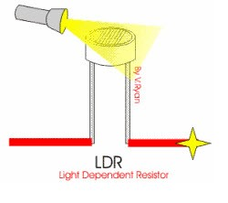

**FIG 6.3 WORKING PRINCIPLE OF LDR**

These devices depend on the light, when light falls on the LDR then the resistance decreases, and increases in the dark. When a LDR is kept in the dark place, its resistance is high and, when the LDR is kept in the light its resistance will decrease. If a constant “V’ is applied to the LDR, the intensity of the light increased and current increases. The figure below shows the curve between resistance Vs illumination curve for a particular light dependent resistor.

### Search in sidebar query**6.1.4 Working**

**FIG 6.4 SCHEMATIC DIAGRAM OF LDR**

The photoconductive material does not consists of any free electrons or it consists of  few free electrons when it is not exposed to light. When the light is incident on the LDR the covalent bond breaks and many free electrons and holes are formed. The free electrons and holes gains energy and they jump from valence band to the conduction band. Thus current is generated. The resistivity of LDR decreases with increase in the incident light. More the light, more the charge carriers.

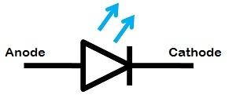6.2 LIGHT EMITTING DIODE

**FIG 6.5 BLOCK DIAGRAM OF LED**

**LED (Light Emitting Diode)** is an **optoelectronic device** which works on the principle of electro-luminance. **Electro-luminance** is the property of the material to convert electrical energy into light energy and later it radiates this light energy. In the same way, the semiconductor in LED emits light under the influence of electric field.

The symbol of LED is formed by merging the symbol of P-N Junction diode and outward arrows. These outward arrows symbolise the light radiated by the light emitting diode. Now, the question arises how the semiconductor material in LED emits light? The answer to this question lies in the construction and working of LED. The symbol of LED is described in the diagram below, the same symbol is used in electronics circuits.

**6.2.1 CONSTRUCTION**

The construction of LED is very simple because it is designed through the deposition of three semiconductor material layers over a substrate. These three layers are arranged one by one where the top region is a P-type region, the middle region is active and finally, the bottom region is N-type. The three regions of semiconductor material can be observed in the construction. In the construction, the P-type region includes the holes; the N-type region includes elections whereas the active region includes both holes and electrons.

When the voltage is not applied to the LED, then there is no flow of electrons and holes so they are stable. Once the voltage is applied then the LED will forward biased, so the electrons in the N-region and holes from P-region will move to the active region. This region is also known as the depletion region. Because the charge carriers like holes include a positive charge whereas electrons have a negative charge so the light can be generated through the recombination of polarity charges.

**6.2.2 INTERNEL STRUCTURE**

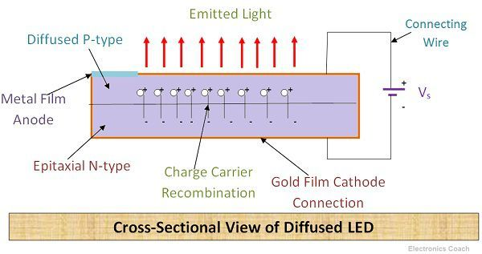The semiconductor layer of **P-type** is placed above **N-type** because the charge carrier recombination occurs in p-type. Besides, it is the surface of the device, thus, the light emitted can be easily seen on the surface. If P-type will be

**FIG 6.6 CROSS SECTIONAL VIEW OF DIFFUSED LED**

**FIG 6.7 SECTIONAL VIEW OF LED**

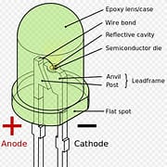placed below the light will be emitted from the surface of P-type but we will not be able to see it. This is the reason that P-type is placed above.

The P-type layer is formed from diffusion of semiconductor material. On the other hand in  N-type region, the epitaxial layer is grown on N-type substrate. The metal film is used on the P-type layer to provide anode connection to the diode. Similarly, Gold-film layer is coated on N-type to provide cathode connection.

Significance of Gold-film Layer

The gold-film layer on N-type also provides reflection from the bottom surface of the diode.  If any significant part of radiated light tends to hit bottom surface then that will be reflected from the bottom surface to the device top surface. This increases LED’s efficiency.

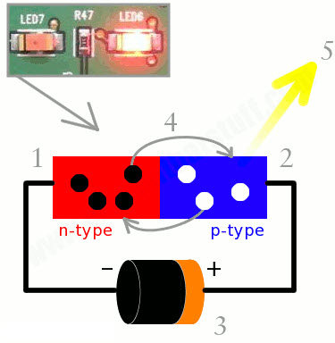**6.2.3 WORKING**

**FIG 6.8 WORKING OF LED**

The electrons are majority carriers in N-type and holes are majority carriers in P-type. The electrons of N-type are in the conduction band and holes of P-type are in the valence band. The energy level of the Conduction band is higher than the energy level of the Valence band. Thus, if electrons tend to recombine with holes they have to lose some part of the energy to fall in lower energy band.

*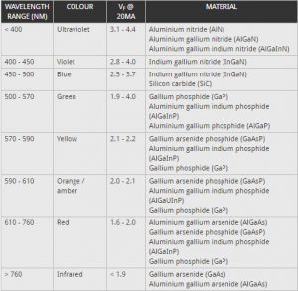*The electrons can lose their energy either in the form of heat or light. The electrons in Silicon and Germanium lose their energy in the form of heat. Thus, they are not used for LEDs as we want semiconductor in which electrons lose their energy in the form of light. Thus, semiconductor compounds such as Gallium Phosphide (Gap), Gallium Arsenide (GaAs), Gallium Arsenide Phosphide (GaAsP) etc. emit light when electrons-holes recombine. The electrons in these compounds lose their energy by **emission of photons.**

**FIG 6.9 FEATURES OF LED**

If the semiconductor material is **translucent**, the light will be emitted from the junction as junction acts as the source of light. LED is operated in forward**biased** mode only. If it will operate in reverse biased it will get damage as it cannot with stand reverse voltage. The above diagram shows how the light-emitting diode works and the step by step process of the diagram.From the above diagram, we can observe that the N-type silicon is in red colour including the electrons which are indicated by the black circles.The P-type silicon is in the blue colour and it contains holes, they are indicated by the white circles. The power supply across the p-n junction makes the diode forward biased and pushing the electrons from n-type to p-type. Pushing the holes in the opposite direction. lectron and holes at the junction are combined. The photons are given off as the electrons and holes are recombined.

#### I-V Characteristics of LED**6.2.4 I-V Characteristics of LED**

#### **FIG 6.10 CHARACTERISTICS OF LED AT DIFFERENT COLOURS**

#### There are different types of light-emitting diodes are available in the market and there are different LED characteristics which include the colour light, or wavelength radiation, light intensity. The important characteristic of the LED is colour. In the starting use of LED, there is the only red colour. As the use of LED is increased with the help of the semiconductor process and doing the research on the new metals for LED, the different colours were formed.

The following graph shows the approximate curves between the forward voltage and the current. Each curve in the graph indicates a different colour. The table shows a summary of the LED characteristics.

#### **6.2.5 Applications of Light Emitting Diode**

There are many applications of LED and some of them are explained below.

* LED is used as a bulb in the homes and industries
* The light-emitting diodes are used in motorcycles and cars
* These are used in mobile phones to display the message
* At the traffic light signals led’s are used

# 6.2.6 ELECTRICAL CHARACTERISTICS OF LEDS: -

Electrically, a LED is similar to the conventional diode in that it has relatively low forward voltage threshold. Once this is exceeded the junction has a low slope resistance and conducts current readily. An external resistor must limit this current. Forward voltage drew across red LED is nominally 1.6 V but spread with commercial diodes, it may be as high as 2 volts or so, while the Green LED drops 2.4V. This difference accounts for use of lower limiting resistor used with the Green LED.

Another important parameter of the LED is its maximum reverse voltage rating. For typical Red device it is of the order of 3 volts. But for Green LED it is somewhat higher- 5 to 10 volts.The LED produces light only when a d.c. current is passed in the forward direction and the amount of light emitted by a LED is proportional to the forward current over a broad range. It means that light intensity increases in an approximately linear manner with increasing current.

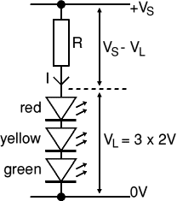**LED resistor formula using Ohm's law**

**FIG 6.11 VOLTAGE DIVIDER FORMULA IN LED**

Ohm's law says that the resistance of the resistor, R = V/I, where:   
  V = voltage across the resistor (= VS - VL in this case)   
  I = the current through the resistor

So   R = (VS - VL) / I

**6.3 PIC MICROCONTROLLER**

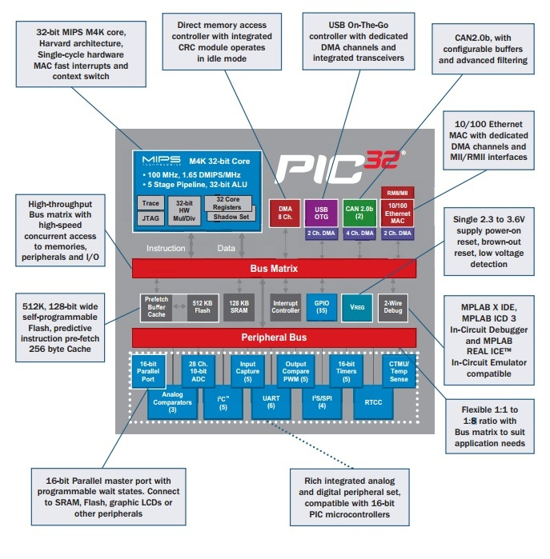**PIC**stands for**“Peripheral Interface Controller”.**And when we try to know about its generations specifically about PIC32, it is cleared to us that constructing on the tradition of Microchip Technology’s domain leading 8 and 16-bit microcontrollers, the **32-bit family offers** a large range of products from the industry’s lowest point to highest-point. The [**architecture of PIC32**](https://microcontrollerslab.com/pic-microcontroller-architecture/) is specially designed so to make “passage” **FIG 6.12 ARCHITECTURE OF PIC MICROCONTROLLER**

from 8-bit and 16-bit architectures seamless and smooth. PIC32 microcontrollers has high performance and high memory. They are especially designed for high performance[**embedded systems applications**](https://microcontrollerslab.com/real-life-examples-embedded-systems/).

The PIC32 is from 32-bit family of wide purpose microcontrollers from Microchip. Technology. It offers 80+ DMIPS performance with a large variety of on-chip peripherals. It occupies industry leading M4K MIPS32 core from MIPS Technologies, Inc. PIC32 microcontrollers are pin-to-pin compatible with PIC24FJ128GA family of 16-bit microcontrollers. In the PIC32 family, all members use programming interface like other Micro-chip PIC microcontrollers.

PIC32 microcontroller has two main series.

* PIC32MX devices
* PIC32MZ devices

### **6.3.1 PIC32 microcontrollers features**

The PIC32 family offers a number of quality ingredients to enable a large variety of applications. The following section list grouped all the key features in major categories.

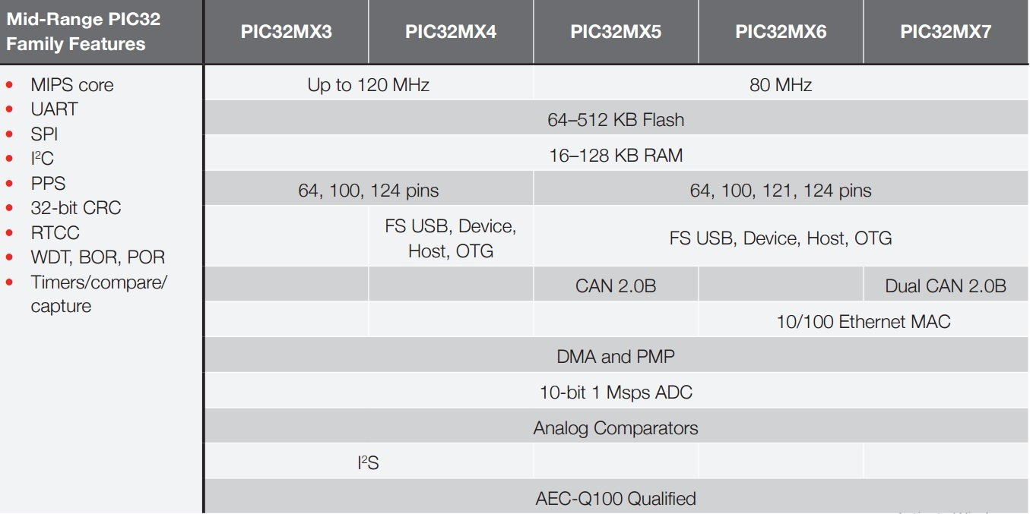

**FIG 6.13 FEATURES OF PIC32 MICROCONTROLLER**

#### Scalability:

* Industry known MIPS32 compatible M4K CPU core with 5(v) stage pipeline
* It’s pin compatible with 64/100 pin PIC24FJXXXGA family of 16-bit microcontrollers
* It has large family of devices with Flash memory options from 32 KB to 512 KB

### Power Management:

* It works from 2.3 to 3.6V
* There are numerous clock sources
* There are various low-power modes including RUN, IDLE and SLEEP
* In it, I/O transfer occurs via DMA in IDLE mode
* In it, programmable peripheral clock is also work
* There is operation during IDLE mode and Individual peripheral do control ON/OFF
* It has full-speed operation over entire voltage range

### Performance:

* Up to 80 MHz, MIPS M4K 32-bit core with 5 (v) stage pipeline
* We can calculate it; high-performance hardware multiply/divide unit 1 multiply/clock
* Multiple register sets for reduced disrupt latency
* Programmable user and kernel memory divide for enhanced application stability
* Hardware assist single cycle register bits manipulations
* To shorten individual instruction fetches time, 128-bit wide Flash memory used
* 256 bytes of high-speed cache memory with useful instructions and ROM data prefetch buffer
* Available DMA controller with pattern based transfer termination and integrated CRC calculation
* Includes USB On-The -Go controller for USB device dual-role, or host applications
* USB controller has its own dedicated DMA interface

### PIC32 ARCHITECTURE

The PIC32 family joins the MIPS M4K core with embedded Flash, powerful peripherals and RAM memory to address a wide range of applications.

Processor core:

* For interrupt handlers, GPR shadow registers to minimize latency
* Bit field manipulation instruction
* High performance Multiply by Divide Unit-The maximum issue rate of one 32×16 multiply /clock
* The maximum issue rate of one 32×32 multiply every other clock
* Its static implementation is minimum operating frequency 0 MHz
* Low power modes including IDLE, RUN and SLEEP
* MIPS M4K with 5 (v) stage pipeline
* MIPS32-compatible Release 2 (II) Instruction Sets
* MIPS16e™ Code Compression to improve its code density up to 40%
* 2.3 to 3.6V operation with full speed over entire set or rang

#### DMA Controller:

* It has up to 4 independent channels
* Memory-to-Peripheral, Memory-to-Memory, and Peripheral-to-Memory transfers
* Integrated programmable CRC engine: calculates on the fly at the time when the data is transferred.
* Programmable activation from any IRQ
* Chainable channels, Auto-Enable mode, stop on match detection
* Data transfers while the core is in IDLE mode

## Memory:

* It has 4GB virtual memory space
* Fixed Memory Mapping Translation mechanism
* User accessible memory segments for increased application stability Flexible partitioning into kernel

### Core Timer:

* It has 32-bit timer in CPU for applying a timer interrupt function.

#### Debug and Programming:

* Read or write access to SFRs and all data RAM without stopping CPU
* Instruction Trace Port:
* 5 Wire which is non intrusive trace port
* activated by complex breakpoints logic block
* 2 data breakpoints and 6 instructions
* 2 complex breakpoint logic blocks with primed breakpoint triggers, stopwatch timers, Pass counters.
* 2 wire Microchip interface and 4 wire EJTAG
* 2 wire Microchip Interface:
* 6 real-time read or write capture logic blocks

#### RTCC (Real-Time Clock and Calendar):

* In it time is with hours, minutes and seconds
* And calendar with weekdays, dates, months and years
* And leap year detection as well
* It has highly configurable alarm
* Calibration is up to 260 pm of crystal error

#### Pre Fetch Cache:

* In it 16 lines, each 128-bit wide, and instruction Prefetch buffer
* And it has ability to lock and load lines which is useful to create SW breakpoints in Flash and have ability to minimize interrupt latency

#### Interrupt Controller:

* Highest priority interrupt has a specific register set to minimize interrupt latency
* Sub priorities and Multiple priorities for each vector
* Fully programmable interrupt controller is there with Single or Multi vector mode, which can support up to 95 IRQs.

#### Enhanced Parallel Master Port:

* 8-bit and 16-bit data interface
* It has expandable using GPIO lines and up to 16-bit address lines
* 2 (II) Chip Select lines

#### Communication channels:

* USB 2.0 compliant (FS 12 Mbps), Host and Device only capable
* 2 Master/Slave/Frame approach SPI channels
* 2 UART channels with hardware IrDA
* 10/7 bits mode addressing, 2 Master/Slave I2C channels, broadcast capable

#### Analog-to-Digital Converters:

* 8 result alignment options
* Operation would be in running during CPU Sleep mode
* Software selectable External and Internal voltage reference
* It has automatic Channel Scan mode
* Up to 16 Channels, each 10-bit resolution ADCs
* The conversion speed is up to 500+ k samples / second (ksps)
* It has choose able conversion trigger source
* And it has16 words conversion result buffer
* Choose able Buffer Fill modes

### Timers:

* 5 16-bit timer/counter ability to form up to 2, 32-bit timer/counters
* It has software choose able internal or external clock source
* It has external pulse counter
* Software chooses able prescalers.
* It is operational in CPU Sleep mode
* Asynchronous timer/counter with a built-in oscillator
* Programmable interrupt priority and generation

**Pin Description:**

PIC16F877A consists of 40 pins enclosed in 5 ports. Each port holds 8 pins which are bidirectional input/output pins. Pin diagram of PIC 16F877 is represented in Fig.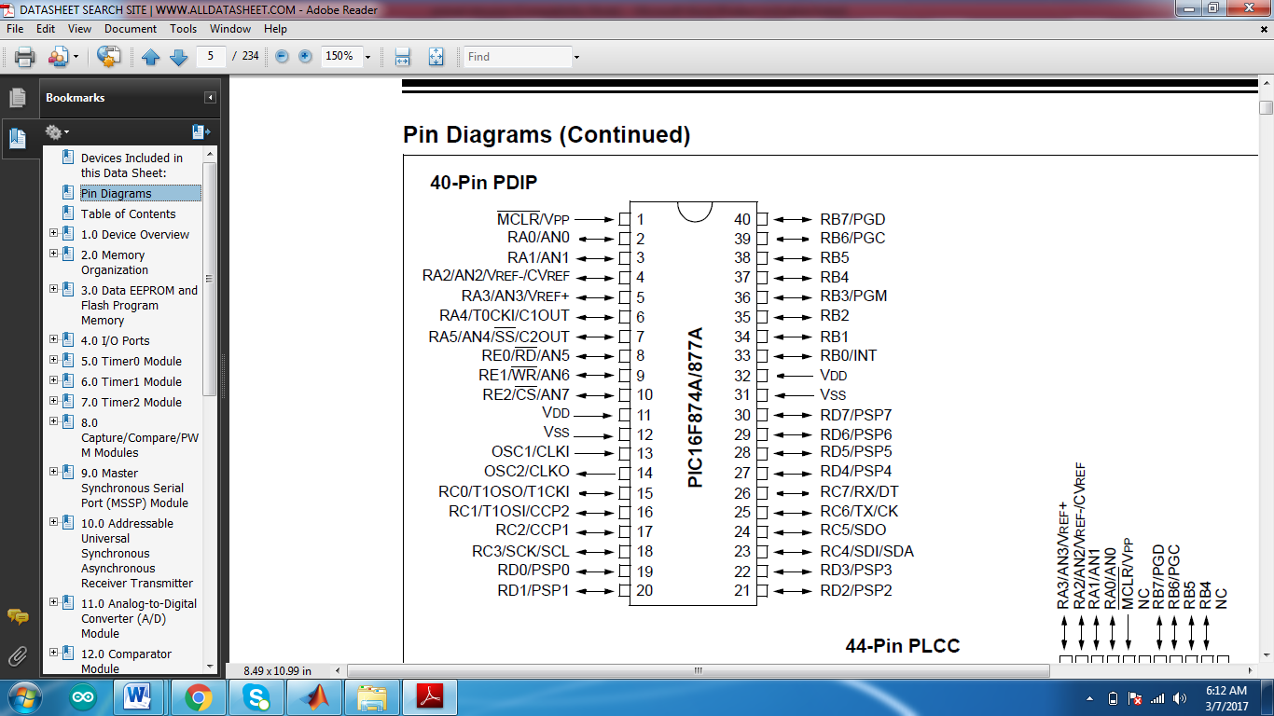

**FIG 6.14 PIN DIAGRAM OF PIC16F MICROCONTROLLER**

**PIN 1: MCLR**

The first pin is the master clear pin of this IC. It resets the microcontroller and is active low, meaning that it should constantly be given a voltage of 5V and if 0 V are given then the controller is reset. Resetting the controller will bring it back to the first line of the program that has been burned into the IC.

[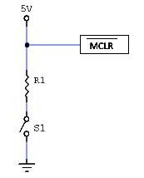](http://microcontrollerslab.com/wp-content/uploads/2015/08/PIC16F877A-reset.jpg)

**FIG 6.15 CIRCUIT DIAGRAM OF PIN 1**

A push button and a resistor is connected to the pin. The pin is already being supplied by constant 5V. When we want to reset the IC we just have to push the button which will bring the MCLR pin to 0 potential thereby resetting the controller.

**PIN 2: RA0/AN0**

PORTA consists of 6 pins, from pin 2 to pin 7, all of these are bidirectional input/output pins. Pin 2 is the first pin of this port. This pin can also be used as an analog pin AN0. It is built in **[analog to digital converter](http://microcontrollerslab.com/analog-to-digital-adc-converter-working/" \t "_blank)**.

**PIN 3: RA1/AN1**

This can be the analog input 1.

**PIN 4: RA2/AN2/Vref-**

It can also act as the analog input2. Or negative analog reference voltage can be given to it.

**PIN 5: RA3/AN3/Vref+**

It can act as the analog input 3. Or can act as the analog positive reference voltage.

**PIN 6: RA0/T0CKI**

To timer0 this pin can act as the clock input pin, the type of output is open drain.

**PIN 7: RA5/SS/AN4**

This can be the analog input 4. There is synchronous serial port in the controller also and this pin can be used as the slave select for that port.

**PIN 8: RE0/RD/AN5**

PORTE starts from pin 8 to pin 10 and this is also a bidirectional input output port. It can be the analog input 5 or for parallel slave port it can act as a ‘read control’ pin which will be active low.

**PIN 9: RE1/WR/AN6**

It can be the analog input 6. And for the parallel slave port it can act as the ‘write control’ which will be active low.

**PIN 10: RE2/CS/A7**

It can be the analog input 7, or for the parallel slave port it can act as the ‘control select’ which will also be active low just like read and write control pins.

**PIN 11 and 32: VDD**

These two pins are the positive supply for the input/output and logic pins. Both of them should be connected to 5V.

**PIN 12 and 31: VSS**

These pins are the ground reference for input/output and logic pins. They should be connected to 0 potential.

**PIN 13: OSC1/CLKIN**

This is the oscillator input or the external clock input pin.

**PIN 14: OSC2/CLKOUT**

This is the oscillator output pin. A crystal resonator is connected between pin 13 and 14 to provide external clock to the microcontroller. ¼ of the frequency of OSC1 is outputted by OSC2 in case of RC mode. This indicates the instruction cycle rate.

[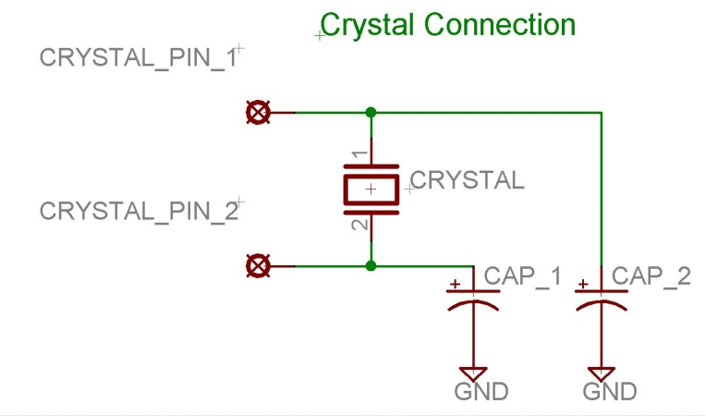](http://microcontrollerslab.com/wp-content/uploads/2015/08/crystal-interfacing-with-PIC16F877A.jpg)

**FIG 6.16 CIRCUIT DIAGRAM OF PIN 14**

**PIN 15: RC0/T1OCO/T1CKI**

PORTC consists of 8 pins. It is also a bidirectional input output port. Of them, pin 15 is the first. It can be the clock input of timer 1 or the oscillator output of timer 2.

**PIN 16: RC1/T1OSI/CCP2**

It can be the oscillator input of timer 1 or the capture 2 input/compare 2 output/ PWM 2 output.

**PIN 17: RC2/CCP1**

It can be the capture 1 input/ compare 1 output/ PWM 1 output.

**PIN 18: RC3/SCK/SCL**

It can be the output for SPI or I2C modes and can be the input/output for synchronous serial clock.

**PIN 23: RC4/SDI/SDA**

It can be the SPI data in pin. Or in I2C mode it can be data input/output pin.

**PIN 24: RC5/SDO**

It can be the data out of SPI in the SPI mode.

**PIN 25: RC6/TX/CK**

It can be the synchronous clock or USART Asynchronous transmit pin.

**PIN 26: RC7/RX/DT**

It can be the synchronous data pin or the USART receive pin.

**PIN 19,20,21,22,27,28,29,30:**

All of these pins belong to PORTD which is again a bidirectional input and output port. When the microprocessor bus is to be interfaced, it can act as the parallel slave port.

**PIN 33-40: PORT B**

All these pins belong to PORTB. Out of which RB0 can be used as the external interrupt pin and RB6 and RB7 can be used as in-circuit debugger pins.

**Architecture of PIC 16F877:**

The basic building block of PIC 16F877A is based on Harvard architecture. The memory of a PIC 16F877A is divided into 3 sections. They are:

* Program memory
* Data Memory
* Data EEPROM

**Program memory**

The PIC 16F877A devices have a 13-bit program counter capable of addressing an 8K word x 14 bit program memory space. The PIC16F877A devices have 8K words x 14 bits of flash program memory.

**Data memory**

The data memory is partitioned into multiple banks which contain the General Purpose Registers and the Special Function Registers. Bits RP1 and RP0 are the bank select bits. The lower locations of each bank are reserved for the Special Function Registers. Above the Special Function Registers are General Purpose Registers, implemented as static RAM. All implemented banks contain Special Function Registers.

**Data EEPROM**

The data EEPROM and flash program memory is readable and writing during normal operation. This memory is not directly mapped in the register file space. Instead, it is indirectly addressed through the special function registers. The EEPROM data memory allows single-byte reads and writes. The flash memory allows single-word reads and four-word block writes.

**Registers:**

The module has four registers for operation. These are:

* Control Register
* Status Register
* Serial Receive/Transmit Buffer Register
* Shift Register

CR and SR are the control and status registers used in operation. The CS register is readable and writable. The lower six bits of the SR are read only. The upper two bits of SR are read/write. SSPSR is the shift register used for shifting data in or out. SSPBUF is the buffer register to which data bytes are written to or read form. In receive operations: SSPSR and SSPBUF together create a double-buffered receiver. During transmission, the SSPBUF is not double-buffered.

**Timer Modules:**

The PIC16F877A incorporates timer modules for the purpose of producing software interrupts. These interrupts are part and parcel of microcontroller programming. There are three timers available. They are:

* Timer0 module
* Timer1 module

**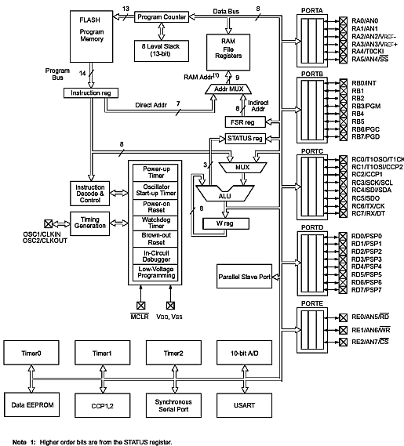**

**FIG 6.17 ARCHITECTURE OF** **PIC16F MICROCONTROLLER**

**Master Synchronous Serial Port (MSSP) Module:**

The Master Synchronous Serial Port (MSSP) module is a serial interface, useful for communicating with other peripheral or microcontroller devices. These peripheral devices may be serial EEPROMs, shift registers, display drivers, A/D converters, etc. The MSSP module can operate in one of two modes:

* + Serial Peripheral Interface (SPI)
  + Inter- Integrated Circuit (I2C)
  + Full Master mode
  + Slave mode (with general address call)

The I2C interface supports the following modes in hardware:

* Master mode
* Multi-Master mode
* Slave mode

**Control Registers:**

The MSSP module has three associated registers. These include a status register (SSPSTAT) and two control registers (SSPCON and SSPCON2). The use of these registers and their individual configuration bits differ significantly, depending on whether the MSSP module is operated in SPI or I2C mode.

**Analog to Converter Module:**

The Analog-to-Digital Converter module has five inputs for the 28-pi devices and eight for the 40/44 pin devices. The conversion of an analog input signal results in a corresponding 10-bit digital number. The A/D module has high and low voltage reference input that is software selectable to some combination of VDD, VSS, RA2 or RA3. The A/D converter has a unique feature of being able to operate while the device is in sleep mode. To operate in sleep mode, the A/D clock must be derived from the A/D internal RC oscillator.

**Core architecture**

The PIC architecture is characterized by the following features:

* Separate code and data spaces ([Harvard architecture](http://en.wikipedia.org/wiki/Harvard_architecture)) for devices other than PIC32, which has a [Von Neumann architecture](http://en.wikipedia.org/wiki/Von_Neumann_architecture).
* A small number of fixed length instructions
* Most instructions are single cycle execution (2 clock cycles), with one delay cycle on branches and skips
* One [accumulator](http://en.wikipedia.org/wiki/Accumulator_(computing)) (W0), the use of which (as source operand) is implied (i.e. is not encoded in the opcode)
* All RAM locations function as registers as both source and/or destination of math and other functions.
* A hardware stack for storing return addresses
* A fairly small amount of addressable data space (typically 256 bytes), extended through banking
* Data space mapped CPU, port, and peripheral registers
* The program counter is also mapped into the data space and writable (this is used to implement indirect jumps).

There is no distinction between memory space and register space because the RAM serves the job of both memory and registers, and the RAM is usually just referred to as the register file or simply as the registers.

**Data space (RAM)**

PICs have a set of registers that function as general purpose RAM. Special purpose control registers for on-chip hardware resources are also mapped into the data space. The addressability of memory varies depending on device series, and all PIC devices have some [banking mechanism](http://en.wikipedia.org/wiki/Bank_switching) to extend addressing to additional memory. Later series of devices feature move instructions which can cover the whole addressable space, independent of the selected bank. In earlier devices, any register move had to be achieved via the accumulator.

To implement indirect addressing, a "file select register" (FSR) and "indirect register" (INDF) are used. A register number is written to the FSR, after which reads from or writes to INDF will actually be to or from the register pointed to by FSR. Later devices extended this concept with post- and pre- increment/decrement for greater efficiency in accessing sequentially stored data. This also allows FSR to be treated almost like a stack pointer (SP).

External data memory is not directly addressable except in some high pin count PIC18 devices.

**Code space**

The code space is generally implemented as [ROM](http://en.wikipedia.org/wiki/Read-only_memory), [EPROM](http://en.wikipedia.org/wiki/EPROM) or [flash ROM](http://en.wikipedia.org/wiki/Flash_memory). In general, external code memory is not directly addressable due to the lack of an external memory interface. The exceptions are PIC17 and select high pin count PIC18 devices.

**Word size**

The word size of PICs can be a source of confusion. All PICs handle (and address) data in 8-bit chunks, so they should be called 8-bit microcontrollers. However, the unit of addressability of the code space is not generally the same as the data space. For example, PICs in the baseline and mid-range families have program memory addressable in the same wordsize as the instruction width, i.e. 12 or 14 bits respectively. In contrast, in the PIC18 series, the program memory is addressed in 8-bit increments (bytes), which differs from the instruction width of 16 bits.

In order to be clear, the program memory capacity is usually stated in number of (single word) instructions, rather than in bytes.

**Stacks**

PICs have a hardware [call stack](http://en.wikipedia.org/wiki/Call_stack), which is used to save return addresses. The hardware stack is not software accessible on earlier devices, but this changed with the 18 series devices.

Hardware support for a general purpose parameter stack was lacking in early series, but this greatly improved in the 18 series, making the 18 series architecture more friendly to high level language compilers.

**Instruction set**

A PIC's instructions vary from about 35 instructions for the low-end PICs to over 80 instructions for the high-end PICs. The instruction set includes instructions to perform a variety of operations on registers directly, the [accumulator](http://en.wikipedia.org/wiki/Accumulator_(computing)) and a literal constant or the accumulator and a register, as well as for conditional execution, and program branching.

Some operations, such as bit setting and testing, can be performed on any numbered register, but bi-operand arithmetic operations always involve W (the accumulator) ; writing the result back to either W or the other operand register. To load a constant, it is necessary to load it into W before it can be moved into another register. On the older cores, all register moves needed to pass through W, but this changed on the "high end" cores.

PIC cores have skip instructions which are used for conditional execution and branching. The skip instructions are: 'skip if bit set', and, 'skip if bit not set'. Because cores before PIC18 had only unconditional branch instructions, conditional jumps are implemented by a conditional skip (with the opposite condition) followed by an unconditional branch. Skips are also of utility for conditional execution of any immediate single following instruction.

The PIC architecture has no (or very meager) hardware support for automatically saving processor state when servicing interrupts. The 18 series improved this situation by implementing shadow registers which save several important registers during an interrupt.

In general, PIC instructions fall into 5 classes:

1. Operation on W with 8-bit immediate ("literal") operand. E.g. movlw (move literal to W), andlw (AND literal with W). One instruction peculiar to the PIC is retlw, load immediate into W and return, which is used with computed [branches](http://en.wikipedia.org/wiki/Branch_(computer_science)) to produce [lookup tables](http://en.wikipedia.org/wiki/Lookup_table).
2. Operation with W and indexed register. The result can be written to either the W register (e.g. addwf *reg*,w). or the selected register (e.g. addwf *reg*,f).
3. Bit operations. These take a register number and a bit number, and perform one of 4 actions: set or clear a bit, and test and skip on set/clear. The latter are used to perform conditional branches. The usual ALU status flags are available in a numbered register so operations such as "branch on carry clear" are possible.
4. Control transfers. Other than the skip instructions previously mentioned, there are only two: goto and call.
5. A few miscellaneous zero-operand instructions, such as return from subroutine, and sleep to enter low-power mode.

**Performance**

The architectural decisions are directed at the maximization of speed-to-cost ratio. The PIC architecture was among the first scalar CPU designs, and is still among the simplest and cheapest. The Harvard architecture—in which instructions and data come from separate sources—simplifies timing and microcircuit design greatly, and this benefits clock speed, price, and power consumption.

The PIC instruction set is suited to implementation of fast lookup tables in the program space. Such lookups take one instruction and two instruction cycles. Many functions can be modelled in this way. Optimization is facilitated by the relatively large program space of the PIC (e.g. 4096 x 14-bit words on the 16F690) and by the design of the instruction set, which allows for embedded constants. For example, a branch instruction's target may be indexed by W, and execute a "RETLW" which does as it is named - return with literal in W.

Execution time can be accurately estimated by multiplying the number of instructions by two cycles; this simplifies design of real-time code. Similarly, interrupt latency is constant at three instruction cycles. External interrupts have to be synchronized with the four clock instruction cycle, otherwise there can be a one instruction cycle jitter. Internal interrupts are already synchronized. The constant interrupt latency allows PICs to achieve interrupt driven low jitter timing sequences. An example of this is a video sync pulse generator.

**6.4 INTERNET OF THINGS (IOT)**

The Internet of things (IoT) is the network of physical devices, vehicles, home appliances and other items [embedded](https://en.wikipedia.org/wiki/Embedded_system) with [electronics](https://en.wikipedia.org/wiki/Electronics), [software](https://en.wikipedia.org/wiki/Software), [sensors](https://en.wikipedia.org/wiki/Sensor), [actuators](https://en.wikipedia.org/wiki/Actuator), and [connectivity](https://en.wikipedia.org/wiki/Internet_access) which enables these objects to connect and exchange [data](https://en.wikipedia.org/wiki/Data). Each thing is uniquely identifiable through its embedded computing system but is able to inter-operate within the existing [Internet](https://en.wikipedia.org/wiki/Internet) infrastructure.

The figure of online capable devices increased 31% from 2016 to 8.4 billion in 2017. Experts estimate that the IoT will consist of about 30 billion objects by 2020. It is also estimated that the global market value of IoT will reach $7.1 trillion by 2020.

The IoT allows objects to be sensed or controlled remotely across existing network infrastructure, creating opportunities for more direct integration of the physical world into computer-based systems, and resulting in improved efficiency, accuracy and economic benefit in addition to reduced human intervention. When IoT is augmented with sensors and actuators, the technology becomes an instance of the more general class of [cyber-physical systems](https://en.wikipedia.org/wiki/Cyber-physical_system), which also encompasses technologies such as [smart grids](https://en.wikipedia.org/wiki/Smart_grid), [virtual power plants](https://en.wikipedia.org/wiki/Virtual_power_plant), [smart homes](https://en.wikipedia.org/wiki/Smart_home), [intelligent transportation](https://en.wikipedia.org/wiki/Intelligent_transportation) and [smart cities](https://en.wikipedia.org/wiki/Smart_city).

"Things", in the IoT sense, can refer to a wide variety of devices such as heart monitoring implants, [biochip](https://en.wikipedia.org/wiki/Biochip) transponders on farm animals, cameras streaming live feeds of wild animals in coastal waters, automobiles with built-in sensors, DNA analysis devices for environmental/food/pathogen monitoring, or field operation devices that assist firefighters in [search and rescue](https://en.wikipedia.org/wiki/Search_and_rescue) operations. Legal scholars suggest regarding "things" as an "inextricable mixture of hardware, software, data and service".

These devices collect useful data with the help of various existing technologies and then autonomously flow the data between other devices

As of 2016, the vision of the Internet of things has evolved due to a convergence of multiple technologies, including ubiquitous wireless communication, real-time [analytics](https://en.wikipedia.org/wiki/Analytics), [machine learning](https://en.wikipedia.org/wiki/Machine_learning), commodity sensors, and [embedded systems](https://en.wikipedia.org/wiki/Embedded_system). This means that the traditional fields of embedded systems, [wireless sensor networks](https://en.wikipedia.org/wiki/Wireless_sensor_network), [control systems](https://en.wikipedia.org/wiki/Control_system), [automation](https://en.wikipedia.org/wiki/Automation)(including [home](https://en.wikipedia.org/wiki/Home_automation) and [building automation](https://en.wikipedia.org/wiki/Building_automation)), and others all contribute to enabling the Internet of things.The concept of a network of smart devices was discussed as early as 1982, with a modified Coke machine at [Carnegie Mellon University](https://en.wikipedia.org/wiki/Carnegie_Mellon_University) becoming the first Internet-connected appliance, able to report its inventory and whether newly loaded drinks were cold. [Mark Weiser](https://en.wikipedia.org/wiki/Mark_Weiser)'s seminal 1991 paper on [ubiquitous computing](https://en.wikipedia.org/wiki/Ubiquitous_computing), "The Computer of the 21st Century", as well as academic venues such as UbiComp and PerCom produced the contemporary vision of IoT. In 1994 Reza Raji described the concept in [IEEE Spectrum](https://en.wikipedia.org/wiki/IEEE_Spectrum) as "[moving] small packets of data to a large set of nodes, so as to integrate and automate everything from home appliances to entire factories". Between 1993 and 1996 several companies proposed solutions like [Microsoft](https://en.wikipedia.org/wiki/Microsoft)'s [at Work](https://en.wikipedia.org/wiki/At_Work) or [Novell](https://en.wikipedia.org/wiki/Novell)'s [NEST](https://en.wikipedia.org/wiki/Novell_Embedded_Systems_Technology). However, only in 1999 did the field start gathering momentum. [Bill Joy](https://en.wikipedia.org/wiki/Bill_Joy) envisioned [Device to Device (D2D)](https://en.wikipedia.org/wiki/Device-to-device)communication as part of his "Six Webs" framework, presented at the World Economic Forum at Davos in 1999.

The concept of the Internet of things became popular in 1999, through the [Auto-ID Center](https://en.wikipedia.org/wiki/Auto-ID_Labs) at [MIT](https://en.wikipedia.org/wiki/Massachusetts_Institute_of_Technology) and related market-analysis publications. Radio-frequency identification ([RFID](https://en.wikipedia.org/wiki/RFID)) was seen by [Kevin Ashton](https://en.wikipedia.org/wiki/Kevin_Ashton) (one of the founders of the original [Auto-ID Center](https://en.wikipedia.org/wiki/Auto-ID_Labs)) as a prerequisite for the Internet of things at that point. [Ashton](https://en.wikipedia.org/wiki/Kevin_Ashton) prefers the phrase "Internet forthings." If all objects and people in daily life were equipped with identifiers, computers could manage and store them.Besides using RFID, the [tagging](https://en.wikipedia.org/wiki/Tag_(metadata)) of things may be achieved through such technologies as [near field communication](https://en.wikipedia.org/wiki/Near_field_communication), [barcodes](https://en.wikipedia.org/wiki/Barcodes), [QR codes](https://en.wikipedia.org/wiki/QR_codes) and [digital watermarking](https://en.wikipedia.org/wiki/Digital_watermarking).

In its original interpretation, one of the first consequences of implementing the Internet of things by equipping all objects in the world with minuscule identifying devices or machine-readable identifiers would be to transform daily life. For instance, instant and ceaseless [inventory control](https://en.wikipedia.org/wiki/Inventory_control) would become ubiquitous. A person's ability to interact with objects could be altered remotely based on immediate or present needs, in accordance with existing [end-user](https://en.wikipedia.org/wiki/End-user) agreements. For example, such technology could grant motion-picture publishers much more control over end-user private devices by remotely enforcing [copyright](https://en.wikipedia.org/wiki/Copyright) restrictions and [digital rights management](https://en.wikipedia.org/wiki/Digital_rights_management), so the ability of a customer who bought a [Blu-ray disc](https://en.wikipedia.org/wiki/Blu-ray_disc) to watch the movie could become dependent on the copyright holder's decision, similar to Circuit City's failed [DIVX](https://en.wikipedia.org/wiki/DIVX).

A significant transformation is to extend "things" from the data generated from devices to objects in the physical space. The thought-model for future interconnection environment was proposed in 2004. The model includes the notion of the ternary universe consists of the physical world, virtual world and mental world and a multi-level reference architecture with the nature and devices at the bottom level followed by the level of the Internet, sensor network, and mobile network, and intelligent human-machine communities at the top level, which supports geographically dispersed users to cooperatively accomplish tasks and solve problems by using the network to actively promote the flow of material, energy, techniques, information, knowledge, and services in this environment. This thought model envisioned the development trend of the Internet of things.

## APPLICATIONS

## Consumer application

## Smart Home

## Media

## Infrastructure Management

## Manufacturing

## Agriculture

## Energy management

## Environmental monitoring

## Building and home automation

## Metropolitan scale deployments

## Medical and healthcare

## Transportation

### **Consumer application**

A growing portion of IoT devices are created for consumer use. Examples of consumer applications include connected car, entertainment, [home automation](https://en.wikipedia.org/wiki/Home_automation) (also known as smart home devices), [wearable technology](https://en.wikipedia.org/wiki/Wearable_technology), [quantified self](https://en.wikipedia.org/wiki/Quantified_Self), connected health, and appliances such as washer/dryers, robotic vacuums, air purifiers, ovens, or refrigerators/freezers that use Wi-Fi for remote monitoring. Consumer IoT provides new opportunities for [user experience](https://en.wikipedia.org/wiki/User_experience) and [interfaces](https://en.wikipedia.org/wiki/User_interface).

Some consumer applications have been criticized for their lack of redundancy and their inconsistency, leading to a popular parody known as the “Internet of Shit.” Companies have been criticized for their rush into IoT, creating devices of questionable value, and not setting up stringent security standards.

#### Smart Home

IoT devices are a part of the larger concept of [home automation](https://en.wikipedia.org/wiki/Home_automation), also known as [domotics](https://en.wikipedia.org/wiki/Domotics" \o "Domotics). Large smart home systems utilize a main hub or controller to provide users with a central control for all of their devices. These devices can include lighting, heating and air conditioning, media and security systems. Ease of usability is the most immediate benefit to connecting these functionalities. Long term benefits can include the ability to create a more environmentally friendly home by automating some functions such as ensuring lights and electronics are turned off. One of the major obstacles to obtaining smart home technology is the high initial cost.

##### **APPLICATIONS**

One key application of smart home is to provide [assistance for disabled and elderly individuals](https://en.wikipedia.org/wiki/Home_automation_for_the_elderly_and_disabled). These home systems utilize assistive technology to accommodate an owner's specific disabilities. Voice control can assist users with sight and mobility limitations while alert systems can be connected directly to Cochlear implants worn by hearing impaired users. They can also be equipped with additional safety features. These features can include sensors that monitor for medical emergencies such as falls or seizures. Smart home technology applied in this way can provide users with more freedom and a higher quality of life.

A second application of smart home is even more sophisticated. One can guide his or her connected device at home even from far away. If one for example leaves the office, it is possible to tell a connected air conditioner device via smart phone to cool down the house to a certain temperature.

#### **AGRICULTURE**

The IoT contributes significantly towards innovating farming methods. Farming challenges caused by population growth and [climate change](https://en.wikipedia.org/wiki/Climate_change) have made it one of the first industries to utilize the IoT. The integration of wireless sensors with agricultural mobile apps and cloud platforms helps in collecting vital information pertaining to the environmental conditions – temperature, rainfall, humidity, wind speed, pest infestation, soil humus content or nutrients, besides others – linked with a farmland, can be used to improve and automate farming techniques, take informed decisions to improve quality and quantity, and minimize risks and wastes. The app-based field or crop monitoring also lowers the hassles of managing crops at multiple locations. For example, farmers can now detect which areas have been fertilised (or mistakenly missed), if the land is too dry and predict future yields.

#### **MEDICAL AND HEALTHCARE**

IoT devices can be used to enable [remote health monitoring](https://en.wikipedia.org/wiki/Remote_patient_monitoring) and [emergency notification systems](https://en.wikipedia.org/wiki/Emergency_notification_system). These health monitoring devices can range from blood pressure and heart rate monitors to advanced devices capable of monitoring specialized implants, such as pacemakers, Fitbit electronic wristbands, or advanced hearing aids.Some hospitals have begun implementing "smart beds" that can detect when they are occupied and when a patient is attempting to get up. It can also adjust itself to ensure appropriate pressure and support is applied to the patient without the manual interaction of nurses.According to the latest research, US Department of Health plans to save up to USD 300 billion from the national budget due to medical innovations.

Specialized sensors can also be equipped within living spaces to monitor the health and general well-being of senior citizens, while also ensuring that proper treatment is being administered and assisting people regain lost mobility via therapy as well. Other consumer devices to encourage healthy living, such as, connected scales or [wearable heart monitors](https://en.wikipedia.org/wiki/Wearable_technology), are also a possibility with the IoT. More and more end-to-end health monitoring IoT platforms are coming up for antenatal and chronic patients, helping one manage health vitals and recurring medication requirements

#### **TRANSPORTATION**

[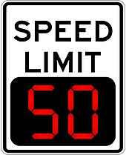](https://en.wikipedia.org/wiki/File:Variable_speed_limit_digital_speed_limit_sign.jpeg)

**FIG 6.18 DIGITAL VARIABLE SPEED-LIMIT SIGN**

The IoT can assist in the integration of communications, control, and information processing across various [transportation systems](https://en.wikipedia.org/wiki/Intelligent_transportation_system). Application of the IoT extends to all aspects of transportation systems (i.e. the vehicle[[100]](https://en.wikipedia.org/wiki/Internet_of_things#cite_note-100), the infrastructure, and the driver or user). Dynamic interaction between these components of a transport system enables inter and intra vehicular communication, [smart traffic control](https://en.wikipedia.org/wiki/Smart_traffic_light), smart parking, [electronic toll collection systems](https://en.wikipedia.org/wiki/Electronic_toll_collection), [logistic](https://en.wikipedia.org/wiki/Logistics_management) and [fleet management](https://en.wikipedia.org/wiki/Fleet_management), [vehicle control](https://en.wikipedia.org/wiki/Autonomous_cruise_control_system), and safety and road assistance. In Logistics and Fleet Management for example, The IoT platform can continuously monitor the location and conditions of cargo and assets via wireless sensors and send specific alerts when management exceptions occur (delays, damages, thefts, etc.).

#### **BUILDING AND HOME AUTOMATION**

IoT devices can be used to monitor and control the mechanical, electrical and electronic systems used in various types of buildings (e.g., public and private, industrial, institutions, or residential)[[41]](https://en.wikipedia.org/wiki/Internet_of_things#cite_note-CoMAN-41) in [home automation](https://en.wikipedia.org/wiki/Home_automation) and [building automation](https://en.wikipedia.org/wiki/Building_automation) systems. In this context, three main areas are being covered in literature:

* The integration of the internet with building energy management systems in order to create energy efficient and IOT driven “smart buildings”.
* The possible means of real-time monitoring for reducing energy consumption and monitoring occupant behaviors.
* The integration of smart devices in the built environment and how they might be used in future applications.

#### **ENVIRONMENTAL MONITORING**

[Environmental monitoring](https://en.wikipedia.org/wiki/Environmental_monitoring) applications of the IoT typically use sensors to assist in environmental protection by monitoring air or [water quality](https://en.wikipedia.org/wiki/Water_quality), [atmospheric](https://en.wikipedia.org/wiki/Air_pollution) or [soil conditions](https://en.wikipedia.org/wiki/Soil_pollution),and can even include areas like monitoring the [movements of wildlife](https://en.wikipedia.org/wiki/Animal_migration_tracking) and their [habitats](https://en.wikipedia.org/wiki/Habitat). Development of resource-constrained devices connected to the Internet also means that other applications like [earthquake](https://en.wikipedia.org/wiki/Earthquake_warning_system) or [tsunami early-warning systems](https://en.wikipedia.org/wiki/Tsunami_warning_system) can also be used by emergency services to provide more effective aid. IoT devices in this application typically span a large geographic area and can also be mobile.[[41]](https://en.wikipedia.org/wiki/Internet_of_things#cite_note-CoMAN-41) It has been argued that the standardization IoT brings to wireless sensing will revolutionize this area.

**ESP 8266- 12E NODE MCU (IOT MODULE)**

NodeMCU is an open source [IoT](https://en.wikipedia.org/wiki/Internet_of_Things) platform. It includes firmware which runs on the [ESP8266](https://en.wikipedia.org/wiki/ESP8266) [Wi-Fi](https://en.wikipedia.org/wiki/Wi-Fi) [SoC](https://en.wikipedia.org/wiki/System_on_a_chip) from [Express if Systems](https://en.wikipedia.org/w/index.php?title=Espressif_Systems&action=edit&redlink=1), and hardware which is based on the ESP-12 module. The term "NodeMCU" by default refers to the firmware rather than the dev kits. The firmware uses the [Lua](https://en.wikipedia.org/wiki/Lua_(programming_language)) scripting language. It is based on the ELua project, and built on the Express if Non-OS SDK for ESP8266. It uses many open source projects, such as lua-cjson, and spiffs.

The Internet of things (IoT) is the network of everyday objects — physical things embedded with electronics, software, sensors, and connectivity enabling data exchange. Basically, a little networked computer is attached to a thing, allowing information exchange to and from that thing. Be it lightbulbs, toasters, refrigerators, flower pots, watches, fans, planes, trains, automobiles, or anything else around you, a little networked computer can be combined with it to accept input (especially object control) or to gather and generate informational output (typically object status or other sensory data). This means computers will be permeating everything around us — ubiquitous embedded computing devices, uniquely identifiable, interconnected across the Internet. Because of low-cost, networkable microcontroller modules, the Internet of things is really starting to take off.

NodeMCU was created shortly after the [ESP8266](https://en.wikipedia.org/wiki/ESP8266) came out. On December 30, 2013, [Espressif Systems](https://en.wikipedia.org/w/index.php?title=Espressif_Systems&action=edit&redlink=1" \o "Espressif Systems (page does not exist)) began production of the ESP8266. The ESP8266 is a Wi-Fi SoC integrated with a Tensilica Xtensa LX106 core, widely used in IoT applications. NodeMCU started on 13 Oct 2014, when Hong committed the first file of nodemcu-firmware to GitHub. Two months later, the project expanded to include an open-hardware platform when developer Huang R committed the [gerber](https://en.wikipedia.org/wiki/Gerber_format" \o "Gerber format) file of an ESP8266 board, named devkit v0.9. Later that month, Tuan PM ported [MQTT](https://en.wikipedia.org/wiki/MQTT) client library from [Contiki](https://en.wikipedia.org/wiki/Contiki) to the ESP8266 SoC platform, and committed to NodeMCU project, then NodeMCU was able to support the MQTT IoT protocol, using Lua to access the MQTT broker. Another important update was made on 30 Jan 2015, when Devsaurus ported the u8glib to NodeMCU project, enabling NodeMCU to easily drive LCD, Screen, OLED, even VGA displays.

ESP8266 ARDUINO CORE

Arduino began developing new MCU boards based on non-AVR processors like the ARM/SAM MCU and used in the Arduino Due, they needed to modify the Arduino IDE so that it would be relatively easy to change the IDE to support alternate tool chains to allow Arduino C/C++ to be compiled down to these new processors. They did this with the introduction of the Board Manager and the SAM Core. A "core" is the collection of software components required by the Board Manager and the Arduino IDE to compile an Arduino C/C++ source file down to the target MCU's machine language. Some creative ESP8266 enthusiasts have developed an Arduino core for the ESP8266 WiFi SoC that is available at the GitHub ESP8266 Core webpage. This is what is popularly called the "ESP8266 Core for the Arduino IDE" and it has become one of the leading software development platforms for the various ESP8266 based modules and development boards, including NodeMCUs.

The Button is a Wi-Fi connected push button designed by [Peter R Jennings](https://en.wikipedia.org/wiki/Peter_R_Jennings).[[11]](https://en.wikipedia.org/wiki/NodeMCU#cite_note-the_button-11) The Button is designed for single-purpose, internet-enabled functions. When the button is pressed, a connection is made to a web server which will perform the desired task. Applications include a doorbell or panic button.

### Node USB

Node USB is an open IoT platform about the size of a standard USB stick. It was designed to leverage NodeMCU ([Lua](https://en.wikipedia.org/wiki/Lua_(programming_language))) for easy programming and has the extra feature of [USB](https://en.wikipedia.org/wiki/USB) capability. It is ideal for Plug-n-Play solutions, allowing easy prototyping for developers

NodeMCU provides access to the [GPIO](https://en.wikipedia.org/wiki/General-purpose_input/output) (General Purpose Input/Output) and for developing purposes below pin mapping table should be referenced.

|  |  |  |  |
| --- | --- | --- | --- |
| IO index | ESP8266 pin | IO index | ESP8266 pin |
| 0 [\*] | GPIO16 | 7 | GPIO13 |
| 1 | GPIO5 | 8 | GPIO15 |
| 2 | GPIO4 | 9 | GPIO3 |
| 3 | GPIO0 | 10 | GPIO1 |
| 4 | GPIO2 | 11 | GPIO9 |
| 5 | GPIO14 | 12 | GPIO10 |
| 6 | GPIO12 |  |  |

**FIG 6.19 INPUT AND OUTPUT PORTS OF PIC16F MICROCONTROLLER**

**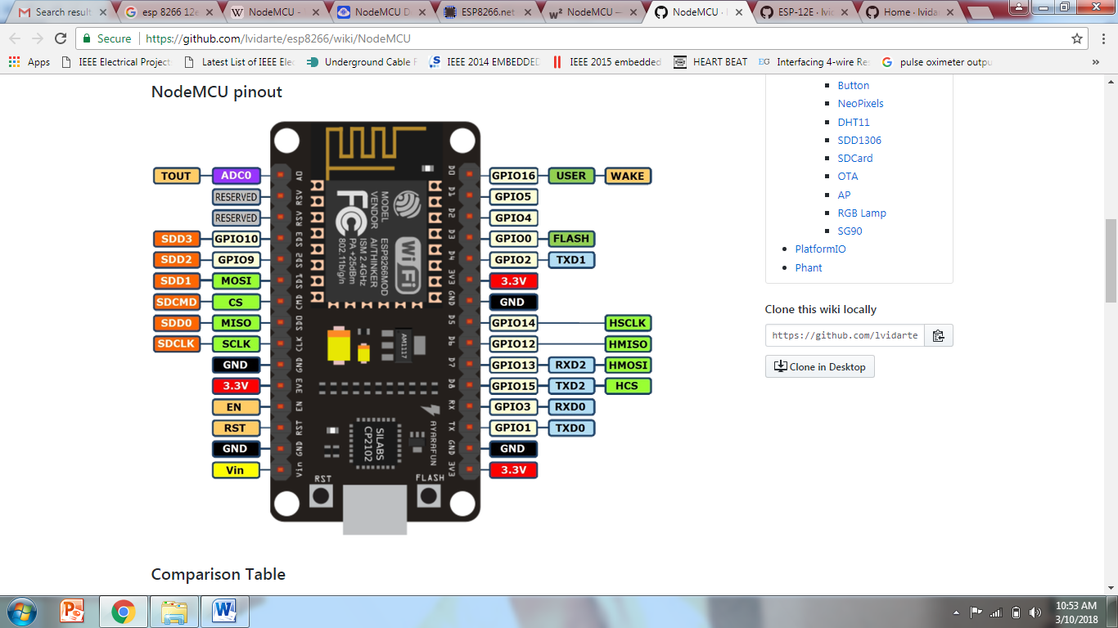FIG 6.20 SCHEMATIC OF NODEMCU**

Node MCU is an open source IoT platform based on the [ESP‐12E](https://github.com/lvidarte/esp8266/wiki/ESP%E2%80%9012E) module. The version 1.0 is the 5th design of NodeMCU devkit. This uses [CP2102](https://www.amazon.co.uk/UART-CP2102-Module-Serial-Converter/dp/B00AFRXKFU) as UART bridge, and can flash firmware automatically by using Nodemcu-flasher. Also it has a voltage regulator to convert from 5v to 3.3v which is the required by the esp21e module.

|  | **NodeMCU v1.0** | **Arduino MKR1000** |
| --- | --- | --- |
| **Microcontroller** | ESP-12E module, with Express if ESP8266 32bits | ARM Cortex M0+ 32bits |
| **Clock Speed** | 80/160MHz | 48MHz |
| **Board Power Supply** | 5V | 5V |
| **Circuit Operating Voltage** | 3.3V | 3.3V |
| **Flash Memory** | 4MB | 256KB |
| **SRAM** | 64KB | 32KB |
| **EEPROM** | No | No |
| **Digital I/O Pins** | 10 | 8 |
| **PWM Pins** | 10 | 12 |
| **Analog Input Pins** | 1 (ADC 10 bit) | 7 (ADC 8/10/12 bit) |
| **Analog Output Pins** |  | 1 (DAC 10 bit) |
| **Connectivity** | IEEE 802.11 b/g/n Wi-Fi | IEEE 802.11 b/g/n Wi-Fi |
| **Antenna Type** | PCB | PCB |
| **Supported Battery** | No | Li-Po single cell, 3.7V, 700mAh minimum |
| **UART** | 1 (+ TX only on pin GPIO2) | 1 |
| **SPI** | 2 | 1 |
| **I2C** | 1 | 1 |
| **LED builtin** | D0 / GPIO 16 | GPIO 6 |
| **Programming Languages** | C++ / Python / Lua / Javascript | C++ |
| **Flashing** | Locally / OTA | Locally / OTA |

### **FIG 6.21 FEATURES OF NODEMCU**

### **CHIP**

The ESP8266 series, or family, of Wi-Fi chips is produced by Espressif Systems, a fabless semiconductor company operating out of Shanghai, China. The ESP8266 series presently includes the ESP8266EX and ESP8285 chips.

ESP8266EX (simply referred to as ESP8266) is a system-on-chip (SoC) which integrates a 32-bit Tensilica microcontroller, standard digital peripheral interfaces, antenna switches, RF balun, power amplifier, low noise receive amplifier, filters and power management modules into a small package. It provides capabilities for 2.4 GHz Wi-Fi (802.11 b/g/n, supporting WPA/WPA2), general-purpose input/output (16 GPIO), Inter-Integrated Circuit (I²C), analog-to-digital conversion (10-bit ADC), Serial Peripheral Interface (SPI), I²S interfaces with DMA (sharing pins with GPIO), UART (on dedicated pins, plus a transmit-only UART can be enabled on GPIO2), and pulse-width modulation (PWM). The processor core, called "L106" by Express if, is based on Tensilica's Diamond Standard 106Micro 32-bit processor controller core and runs at 80 MHz (or overclocked to 160 MHz). It has a 64 KiB boot ROM, 32 KiB instruction RAM, and 80 KiB user data RAM. (Also, 32KB instruction cache RAM and 16 KiB ETS system data RAM.) External flash memory can be accessed through SPI. The silicon chip itself is housed within a 5 mm × 5 mm Quad Flat No-Leads package with 33 connection pads — 8 pads along each side and one large thermal/ground pad in the cent.

**6.5 POWER SUPPLY**

Power supply is a reference to a source of electrical power. A device or system that supplies electrical or other types of energy to an output load or group of loads is called a power supply unit or PSU. The term is most commonly applied to electrical energy supplies, less often to mechanical ones, and rarely to others.

Power supplies for electronic devices can be broadly divided into linear and switching power supplies. The linear supply is a relatively simple design that becomes increasingly bulky and heavy for high current devices; voltage regulation in a linear supply can result in low efficiency. A switched-mode supply of the same rating as a linear supply will be smaller, is usually more efficient, but will be more complex.

**6.5.1. LINEAR POWER SUPPLY**

An AC powered linear power supply usually uses a transformer to convert the voltage from the wall outlet (mains) to a different, usually a lower voltage. If it is used to produce DC, a rectifier is used. A capacitor is used to smooth the pulsating current from the rectifier. Some small periodic deviations from smooth direct current will remain, which is known as ripple. These pulsations occur at a frequency related to the AC power frequency (for example, a multiple of 50 or 60 Hz).

The voltage produced by an unregulated power supply will vary depending on the load and on variations in the AC supply voltage. For critical electronics applications a linear regulator will be used to stabilize and adjust the voltage. This regulator will also greatly reduce the ripple and noise in the output direct current. Linear regulators often provide current limiting, protecting the power supply and attached circuit from over current.

Adjustable linear power supplies are common laboratory and service shop test equipment, allowing the output voltage to be set over a wide range. For example, a bench power supply used by circuit designers may be adjustable up to 30 volts and up to 5 amperes output. Some can be driven by an extema] signal, for example, for applications requiring a pulsed output.

**FIG 6.22 BLOCK DIAGRAM OF RPS**

**6.5.2 BATTERY POWER SUPPLY**

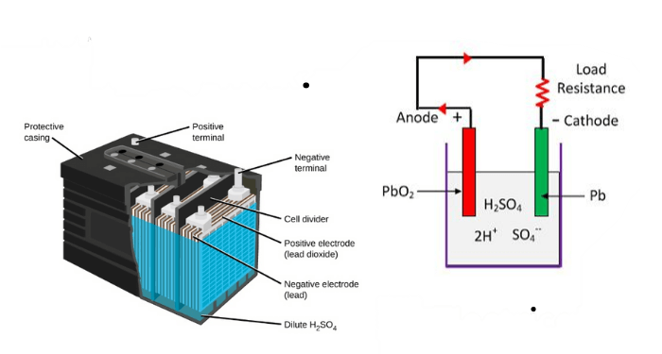A battery is a portable power supply that stores electrical energy in a chemical form and supplies it as direct current (DC) when needed. Batteries are used in a wide range of applications, including powering portable electronic devices, such as cell phones and laptops, as well as providing backup power for homes and businesses.

**FIG 6.23 CROSS SECTION OF BATTERY POWER SUPPLY**

One of the main advantages of battery power is that it is portable and can be taken anywhere. This makes batteries an ideal choice for powering devices that need to be used on the go, such as cell phones and laptops. Batteries are also useful for providing backup power in case of an outage or other emergency situation.

Another advantage of battery power is that it is relatively easy to use. Most batteries are plug-and-play, meaning that they can be easily inserted into a device and used immediately. There is also a wide range of battery sizes and types available, making it easy to find a battery that is suitable for a particular application. However, batteries do have some limitations. One of the main drawbacks is that they eventually run out of power and need to be replaced or recharged. This can be inconvenient if you are in a situation where you need to use your device for an extended period of time without access to a power source. Additionally, batteries can be expensive, especially if you need to purchase multiple replacements.

Overall, battery power is a convenient and widely used form of power supply that is suitable for a wide range of applications. It is portable, easy to use, and reliable, but it does have some limitations, such as a limited lifespan and the need for periodic replacement or recharging.

A lead acid battery is a type of rechargeable battery that uses lead and lead oxide as the cathode and anode, respectively, and sulfuric acid as the electrolyte. It is one of the oldest and most widely used types of batteries, with a history dating back to the mid-19th century.

Lead acid batteries are commonly used in a variety of applications, including starting and lighting (SLI) batteries for vehicles, backup power systems for homes and businesses, and as a primary power source for electric vehicles. They are also used in a variety of other applications, such as boats, recreational vehicles, and solar power systems.

One of the main advantages of lead acid batteries is their low cost. They are relatively inexpensive compared to other types of batteries, making them an attractive choice for many applications. They also have a relatively long lifespan, with some models capable of lasting for several years.

However, lead acid batteries do have some drawbacks. They are relatively heavy and bulky, making them less suitable for portable applications. They also require periodic maintenance, such as adding water to the cells to keep the electrolyte at the proper level. In addition, lead acid batteries can be damaged if they are overcharged or discharged too deeply.

Overall, lead acid batteries are a reliable and widely used type of battery that are suitable for a variety of applications. While they do have some limitations, their low cost and long lifespan make them an attractive choice for many applications.

**6.6. TRANSFORMER**

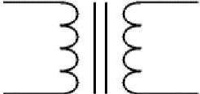

**FIG 6.24 TRANSFORMER**

Transformers conve1t AC electricity from one voltage to another with little loss of power. Transformers work only with AC and this is one of the reasons why mains electricity is AC.

Step-up transformers increase voltage, step-down transformers reduce voltage. Most power supplies use a step-down transformer to reduce the dangerously high mains voltage (230V in UK) to a safer low voltage.

The input coil is called the primary and the output coil is called the secondary. There is no electrical connection between the two coils; instead they are linked by an alternating magnetic field created in the soft-iron core of the transformer. The two lines in the middle of the circuit symbol represent the core. Transformers waste very little power so the power out is (almost) equal to the power in. Note that as voltage is stepped down current is stepped up.

The ratio of the number of turns on each coil, called the tum's ratio, determines the ratio of the voltages. A step-down transformer has a large number of turns on its primary (input) coil which is connected to the high voltage mains supply, and a small number of turns on its secondary (output) coil to give a low output voltage.

Turns ratio=VpNs=Nn/Ns and Power out=Power in Vs\*ls=Vp \* Ip

Where,

Vp = primary (input) voltage

Np = number of turns on primary coil Ip = primary (input) current

Vs= secondary (output) voltage

Ns = number of turns on secondary coil Is = secondary (output)current.

**6.6. RECTIFIER**

There are several ways of connecting diodes to make a rectifier to convert AC to DC. The bridge rectifier is the most important and it produces full-wave varying DC. A full-wave rectifier can also be made from just two diodes if a centre-tap transformer is used, but this method is rarely used now that diodes are cheaper. A single diode can be used as a rectifier but it only uses the positive (+) parts of the AC wave to produce half-wave varying DC.

he varying DC output is suitable for lamps, heaters and standard motors. It is not suitable for electronic circuits unless they include a smoothing capacitor.



**FIG 6.25 OUTPUT WAVEFORM**

**6.6.1. BRIDGE RECTIFIER**

A bridge rectifier can be made using four individual diodes, but it is also available in special packages containing the four diodes required. It is called a fu11- wave rectifier because it uses the entire AC wave (both positive and negative sections). 1.4V is used up in the bridge rectifier because each diode uses 0.7V when conducting and there are always two diodes conducting, as shown in the diagram below. Bridge rectifiers are rated by the maximum current they can pass and the maximum reverse voltage they can withstand (this must be at least three times the supply RMS voltage so the rectifier can withstand the peak voltages). Please see the

**FIG 6.26 FULL WAVE BRIDGE RECTIFIER**

Diodes page for more details, including pictures of ridge rectifiers**.**Alternate pairs of diodes conduct, changing over the connections so the alternating directions of AC are converted to the one direction of DC.

**FIG 6.27 OUTPUT OF BRIDGE RECTIFIER**

**6.6.2. SINGLE DIODE RECTIFIER**

A single diode can be used as a rectifier but this produces **half-wave** varying DC which has gaps when the AC is negative. It is bard to smooth this sufficiently well to supply electronic circuits unless they require a very small current so the smoothing capacitor does not significantly discharge during the gaps. Please see the ****Diodes page for some examples of rectifier diodes.

**FIG 6.28 OUTPUT OF SINGLE DIODE RECTIFIER**

**6.6.3. SMOOTHING**

Smoothing is performed by a large value electrolytic capacitor connected across the DC supply to act as a reservoir, supplying current to the output when the varying DC voltage from the rectifier is falling. The diagram shows the unsmoothed varying DC and the smoothed DC. The capacitor charges quickly near the peak of

**FIG 6.29 SMOOTHING CURVE**

the varying DC, and then discharges as it supplies current to the output.

Note that smoothing significantly increases the average DC voltage to almost the peak value (1.4 x RMS value). For example 6V RMS AC is rectified to full wave DC of about 4.6V RMS (1.4V is lost in the bridge rectifier), with smoothing this increases to almost the peak value giving 1.4 x 4.6 = 6.4V smooth DC.

Smoothing is not perfect due to the capacitor voltage falling a little as it discharges, giving a small ripple voltage. For many circuits a ripple which is 10% of the supply voltage is satisfactory and the equation below gives the required value for the smoothing capacitor. A larger capacitor will give fewer ripples. The capacitor value must be doubled when smoothing half-wave DC.

Smoothing Capacitor for 10% ripple, *C=S\**10/vs.\*f C = smoothing capacitance in farads (F)

Io = output current from the supply in amps (A)

Vs = supply voltage in volts (V), this is the peak value of the unsmoothed DC f = frequency of the AC supply in hertz (Hz), 50Hz in the UK.

he smooth DC output has a small ripple. It is suitable for most electronic circuits.

**CHAPTER 7**

**SOFTWARE DESCRIPTION**

**7.1 SOFTWARE DESCRIPTION**

In the getting started guide (Windows, Mac OS X, Linux), you uploaded a sketch that blinks an LED. In this tutorial, you'll learn how each part of that sketch works. A sketch is the name that Arduino uses for a program. It's the unit of code that is uploaded to and run on an Arduino board.

Arduino is an open source, computer hardware and software company, project, and user community that designs and manufactures microcontroller kits for building digital devices and interactive objects that can sense and control objects in the physical world. The project's products are distributed as open-source hardware and software, which are licensed under the GNU Lesser General Public License (LGPL) or the GNU General Public License (GPL), permitting the manufacture of Arduino boards and software distribution by anyone. Arduino boards are available commercially in preassembled form, or as do-it-yourself kits.

Arduino board designs use a variety of microprocessors and controllers. The boards are equipped with sets of digital and analog input/output (I/0) pins that may be interfaced to various expansion boards (shields) and other circuits. The boards feature serial communications interfaces, including Universal Serial Bus (USB) on some models, which are also used for loading programs from personal computers. The microcontrollers are typically programmed using a dialect of features from the programming languages C and C++. In addition to using traditional compiler toolchains, the Arduino project provides an integrated development environment (IDE) based on the Processing language project.

The Arduino project started in 2003 as a program for students at the Interaction Design Institute Ivrea in Ivrea, Italy, aiming to provide a low-cost and easy way for novices and professionals to create devices that interact with their environment using sensors and actuators. Common examples of such devices intended for beginner hobbyists include simple robots, thermostats, and motion detectors.

**7.2 ARDUINO IDE**

Arduino is an open-source electronics platform based on easy-to-use hardware and software. Arduino boards are able to read inputs - light on a sensor, a finger on a button, or a Twitter message - and tum it into an output - activating a motor, turning on an LED, publishing something online. You can tell your board what to do by sending a set of instructions to the microcontroller on the board. To do so you use the Arduino programming language (based on Wiring), and the Arduino Software (IDE), based on Processing.

Over the years Arduino has been the brain of thousands of projects, from everyday objects to complex scientific instruments. A worldwide community of makers - students, hobbyists, artists, programmers, and professionals - has gathered around this open-source platform, their contributions have added up to an incredible amount of accessible knowledge that can be of great help to novices and experts alike.

Arduino was born at the Ivrea Interaction Design Institute as an easy tool for fast prototyping, aimed at students without a background in electronics and programming. As soon as it reached a wider community, the Arduino board started changing to adapt to new needs and challenges, differentiating its offer from simple 8-bit boards to products for IoT applications, wearable, 3D printing, and embedded environments. All Arduino boards are completely open-source, empowering users to build them independently and eventually adapt them to their particular needs. The software, too, is open-source, and it is growing through the contributions of users worldwide.

There are many other microcontrollers and microcontroller platforms available for physical computing. Parallax Basic Stamp, Netmedia's BX-24, Phidgets, MIT's Handy board, and many others offer similar functionality. All of these tools take the messy details of microcontroller programming and wrap it up in an easy-to-use package. Arduino also simplifies the process of working with microcontrollers, but it offers some advantage for teachers, students, and interested amateurs over other systems:

* Inexpensive - Arduino boards are relatively inexpensive compared to other microcontroller platforms. The least expensive version of the Arduino module can be assembled by hand, and even the pre-assembled Arduino modules cost less than $50
* Cross-platform - The Arduino Software (IDE) on Windows, Macintosh OSX, and Linux operating systems. Most microcontroller systems are limited to Windows.
* Simple, clear programming environment - The Arduino Software (IDE) is easy­ to-use for beginners, yet flexible enough for advanced users to take advantage of as well. For teachers, it's conveniently based on the Processing programming environment, so students learning to program in that environment will be familiar with how the Arduino IDE works.
* Open source and extensible software - The Arduino software is published as opensource tools, available for extension by experienced programmers. The language can be expanded through C++ libraries, and people wanting to understand the technical details can make the leap from Arduino to the AVR C programming language on which it's based. Similarly, you can add AVR-C code directly into your Arduino programs if you want to.
* Open source and extensible hardware - The plans of the Arduino boards are published under a Creative Commons license, so experienced circuit designers can make their own version of the module, extending it and improving it. Even relatively inexperienced users can build the breadboard version of the module in order to understand how it works and save money.

**7.3 ARDUINO PROGRAMMING**

**7.3.1 VARIABLES**

A variable is a place for storing a piece of data. It has a name, a type, and a value. For example, the line from the Blink sketch above declares a variable with the name led Pin, the type int, and an initial value of 13. It's being used to indicate which Arduino pin the LED is connected to. Every time the name led Pin appears in the code, its value will be retrieved. In this case, the person writing the program could have chosen not to bother creating the led Pin variable and instead have simply written 13 everywhere they needed to specify a pin number. The advantage of using a variable is that it's easier to move the LED to a different pin: you only need to edit the one line that assigns the initial value to the variable.

**7.3.2 FUNCTIONS**

A function (otherwise known as a procedure or sub-routine) is a named piece of code that can be used from elsewhere in a sketch. For example, here's the definition of the setup() function from the Blink example:

void setup()

{

pinMode(ledPin, OUTPUT);

}

The first line provides information about the function, like its name, "setup". The text before and after the name specify its return type and parameters: these will be explained later. The code between the { and } is called the body of the function: what the function does.

pinMode(), digitalWrite(), and delay()

The pinMode() function configures a pin as either an input or an output. To use it, you pass it the number of the pin to configure and the constant INPUT or OUTPUT. When configured as an input, a pin can detect the state of a sensor like a pushbutton; As an output, it can drive an actuator like an LED.

The digitalWrite() functions outputs a value on a pin. For example, the line:

digitalWrite(ledPin, HIGH);

The delay() causes the Arduino to wait for the specified number of milliseconds before continuing on to the next line. There are 1000 milliseconds in a second, so the line:

### delay(l000);

setup() and loop()

There are two special functions that are a part of every Arduino sketch: setup() and loop(). The setup() is called once, when the sketch starts. It's a good place to do setup tasks like setting pin modes or initializing libraries. The loop() function is called over and over and is heart of most sketches. You need to include both functions in your sketch, even if you don't need them for anything.

Everything between the/\* and\*/ is ignored by the Arduino when it runs the sketch (the\* at the start of each line is only there to make the comment look pretty, and isn't required). It's there for people reading the code: to explain what the program does, how it works, or why it's written the way it is. It's a good practice to comment your sketches, and to keep the comments up-to-date when you modify the code. This helps other people to learn from or modify your code.

**7.3.3 CODE UPLOADED**

**7.3.3.1 CODE FOR PIC MICROCONTROLLER**

#include<pic.h>

\_\_CONFIG(0X3F72);

static bit rs@((unsigned )&PORTD\*8+1);

static bit rw@((unsigned )&PORTD\*8+2);

static bit en@((unsigned )&PORTD\*8+3);

static bit led1@((unsigned )&PORTC\*8+0);

static bit led2@((unsigned )&PORTC\*8+1);

stat ic bit led3@((unsigned )&PORTC\*8+2);

unsigned int HB,VAL1=0,VAL2=0,VAL3=0;

//unsigned char VAL4=0,VAL5=0;

unsigned int L1,L2,L3,VALX,VALY,VALZ;

unsigned char VALA=0, VALB=0,VALC=0;

unsigned char i,j,k,m;

unsigned int res,spo2, COUNT,adc\_value,a,b,c,e,f,g,z,h;

unsigned int VAL4=0, adc\_value2,l,n,o,VAL5=0;

unsigned char s1,H1,H2,H3,T1,T2,T3,M1,M2,M3;

unsigned char Z1=0,Z2=0,Z3=0;

unsigned char VIK=0,ser=0x37,st=0x01,data\_cap=0x00;

unsigned char adc=0,V1,V2,V3,V4,V5;

void delay(unsigned int y)//delay prg

{

while(y--);

}

//\*\*\*\*\*\*\*\*\*\*\*\*\*\*\*\*\*\*\*\*\*\*\*\*\*\*\*\*\*\*\*\*\*\*\*\*\*\*\*\*\*\*\*\*\*\*\*\*\*\*\*\*\*\*\*\*\*\*\*\*\*\*\*\*\*\*\*\*

// SERIAL INTRRUPT

//\*\*\*\*\*\*\*\*\*\*\*\*\*\*\*\*\*\*\*\*\*\*\*\*\*\*\*\*\*\*\*\*\*\*\*\*\*\*\*\*\*\*\*\*\*\*\*\*\*\*\*\*\*\*\*\*\*\*\*\*\*\*\*\*\*\*\*\*

void interrupt rcx(void)

{

if(RCIF==1)

{

RCIF=0;

ser=RCREG;

if(ser=='E')

{

VAL4=1;VAL5=0;

}

if(ser=='B')

{

VAL4=0;VAL5=1;

}

}

}

void delay2()

{

long i;

for(i=0;i<10000;i++);

CLRWDT();

}

//\*\*\*\*\*\*\*\*\*\*\*\*\*\*\*\*\*\*\*\*\*\*\*\*\*\*\*\*\*\*\*\*\*\*\*\*\*\*\*\*\*\*\*\*\*\*\*\*\*\*\*\*\*\*\*\*\*\*\*\*\*\*\*\*\*\*\*\*

// GPS AND GSM INIT

//\*\*\*\*\*\*\*\*\*\*\*\*\*\*\*\*\*\*\*\*\*\*\*\*\*\*\*\*\*\*\*\*\*\*\*\*\*\*\*\*\*\*\*\*\*\*\*\*\*\*\*\*\*\*\*\*\*\*\*\*\*\*\*\*\*\*\*\*

void iot\_init()

{

TXSTA=0X24;

RCSTA=0X90;

SPBRG=25;

BRGH=1;

}

void gsm\_command(const unsigned char \*da,unsigned int y)

{

unsigned int s;

for(s=0;s<=y;s++)

{

while(!TXIF)

{

}

//delay2();

OERR=0;

TXREG=da[s];

//delay(2000);

}

}

void txs(unsigned char val)

{

while(!TXIF)

{

}

//delay2();

OERR=0;

TXREG=val;

}

//\*\*\*\*\*\*\*\*\*\*\*\*\*\*\*\*\*\*\*\*\*\*\*\*\*\*\*\*\*\*\*\*\*\*\*\*\*\*\*\*\*\*\*\*\*\*\*\*\*\*\*\*\*\*\*\*\*\*\*\*\*\*\*\*\*\*\*\*

//IOT

//\*\*\*\*\*\*\*\*\*\*\*\*\*\*\*\*\*\*\*\*\*\*\*\*\*\*\*\*\*\*\*\*

void IOT\_SEND()

{

TXREG='V';

delay(100);

TXREG=(H1);

delay(600);

TXREG=(H2);

delay(600);

TXREG=(H3);

delay(600);

TXREG='I';

delay(100);

TXREG=(T1);

delay(600);

TXREG=(T2);

delay(600);

TXREG=(T3);

delay(600);

TXREG='T';

delay(100);

TXREG=(M1);

delay(600);

TXREG=(M2);

delay(600);

TXREG=(M3);

delay(600);

}

//\*\*\*\*\*\*\*\*\*\*\*\*\*\*\*\*\*\*\*\*\*\*\*\*\*\*\*\*\*\*\*\*\*\*\*\*\*\*\*\*\*\*\*\*\*\*\*\*\*\*\*\*\*\*\*\*\*

//SENSOR

//\*\*\*\*\*\*\*\*\*\*\*\*\*\*\*\*\*\*\*\*\*\*\*\*\*\*\*\*\*\*\*\*\*\*\*\*\*\*\*\*\*\*\*\*\*\*\*\*\*\*\*\*\*\*\*\*\*

void sensor()

{

lcd\_command(0x01);

delay(100);

lcd\_command(0x80);

delay(100);

CHS0=0;

CHS1=0;

CHS2=0;

ADON=1;

delay(200);

ADCON0=ADCON0|0X04;

delay(200);

adc\_value=ADRESH;

adc\_value=adc\_value<<8;

adc\_value=(adc\_value+ADRESL)/0x02;

VAL1=adc\_value;

if(VALA==1)

{

VALA=0;

VALX=adc\_value;

}

//adc\_value=adc\_value/0x02;

delay(100);

lcd\_command(0x82);

delay(100);

adcconvert1();

delay(10000);

CHS0=1;

CHS1=0;

CHS2=0;

ADON=1;

delay(200);

ADCON0=ADCON0|0X04;

delay(200);

adc\_value=ADRESH;

adc\_value=adc\_value<<8;

adc\_value=(adc\_value+ADRESL)/0x02;

VAL2=adc\_value;

if(VALB==1)

{

VALB=0;

VALY=adc\_value;

}

delay(100);

lcd\_command(0x87);

delay(100);

adcconvert2();

delay(10000);

CHS0=0;

CHS1=1;

CHS2=0;

ADON=1;

delay(200);

ADCON0=ADCON0|0X04;

delay(200);

adc\_value=ADRESH;

adc\_value=adc\_value<<8;

adc\_value=(adc\_value+ADRESL)/0x02;

VAL3=adc\_value;

delay(100);

if(VALC==1)

{

VALC=0;

VALZ=adc\_value;

}

lcd\_command(0x8d);

delay(100);

adcconvert3();

delay(10000);

}

//\*\*\*\*\*\*\*\*\*\*\*\*\*\*\*\*\*\*\*\*\*\*\*\*\*\*\*\*\*\*\*\*\*\*\*\*\*\*\*\*\*\*\*\*\*\*\*\*\*\*\*\*\*\*\*\*\*\*\*\*\*\*\*\*\*\*\*\*

// main

//\*\*\*\*\*\*\*\*\*\*\*\*\*\*\*\*\*\*\*\*\*\*\*\*\*\*\*\*\*\*\*\*\*\*\*\*\*\*\*\*\*\*\*\*\*\*\*\*\*\*\*\*\*\*\*\*\*\*\*\*\*\*\*\*\*\*\*\*

void main()

{

ADCON1=0X80;

ADCON0=0x00;

TRISB=0XFF;

TRISD=0X00;

TRISC=0X80;

TRISA=0X0f;

TRISE=0X00;

PORTA=0X00;

PORTD=0X00;

PORTB=0XFF;

PORTC=0X80;

PORTE=0X00;

delay(35000);delay(35000);

delay(1000);

lcd\_init();

delay(1000);

lcd\_command(0x01);

delay(50000);

lcd\_command(0x80);

delay(100);

lcd\_display("T: X: ",15);

lcd\_command(0xC0);

delay(100);

lcd\_display("H: : ",15);

delay(10000);

delay(35000);

iot\_init();

GIE=1;

PEIE=1;

RCIE=1;

delay(35000);

delay(100);

lcd\_command(0x80);

delay(100);

lcd\_display("welcome",7);

VAL1=0;

delay(10000);

//\*\*\*\*\*\*\*\*\*\*\*\*\*\*\*\*\*\*\*\*\*\*\*\*\*\*\*\*\*\*\*\*\*\*\*\*\*\*\*\*\*\*\*\*\*\*\*\*\*\*\*\*\*\*\*\*\*\*\*\*\*\*\*\*\*\*\*

// while

//\*\*\*\*\*\*\*\*\*\*\*\*\*\*\*\*\*\*\*\*\*\*\*\*\*\*\*\*\*\*\*\*\*\*\*\*\*\*\*\*\*\*\*\*\*\*\*\*\*\*\*\*\*\*\*\*\*\*\*\*\*\*\*\*\*\*\*

while(1)

{

if(VAL4==1)

{

VAL4=0;

led1=1;led2=0;led3=0;VALA=1;

delay(50000);delay(50000);delay(50000);delay(50000);

sensor();

delay(50000);delay(50000);delay(50000);delay(50000);

led1=0;led2=1;led3=0;VALB=1;

delay(50000);delay(50000);delay(50000);delay(50000);

sensor();

delay(50000);delay(50000);delay(50000);delay(50000);

led1=0;led2=0;led3=1;VALC=1;

delay(50000);delay(50000);delay(50000);delay(50000);

sensor();

delay(50000);delay(50000);delay(50000);delay(50000);

delay(50000);delay(50000);

if((VALX<=385)&&(VALY<410)&&(VALZ>50))

{

lcd\_command(0xCF);

delay(100);

lcd\_data('N');

TXREG='A';

delay(100);

TXREG='1';

delay(600);

}

else

{

Z1=1;

TXREG='A';

delay(100);

TXREG='0';

delay(600);

}

if(((VALX>385)&&(VALX<=396))&&((VALY>410)&&(VALY<420)))

{

lcd\_command(0xCF);

delay(100);

lcd\_data('J');

TXREG='B';

delay(100);

TXREG='1';

delay(600);

}

else

{

Z2=1;

TXREG='B';

delay(100);

TXREG='0';

delay(600);

}

if((VALX>395)&&(VALY>420)&&(VALZ<30))

{

lcd\_command(0xCF);

delay(100);

lcd\_data('H');

TXREG='C';

delay(100);

TXREG='1';

delay(600);

}

else

{

Z3=1;

TXREG='C';

delay(100);

TXREG='0';

delay(600);

}

if((Z1==1)&&(Z2==1)&&(Z3==1))

{

TXREG='D';

delay(100);

TXREG='1';

delay(600);

Z1=0;Z2=0;Z3=0;

}

else

{

TXREG='D';

delay(100);

TXREG='0';

delay(600);

}VAL4=0;

}

/\*IOT\_SEND();

delay(50000);delay(20000);delay(20000);

if(VAL4==1)

{

VAL4=0;TXREG='Z';

delay(100);

TXREG='1';

delay(600);

}

if(VAL5==1)

{

VAL5=0;

TXREG='Z';

delay(100);

TXREG='0';

delay(600);

}

\*/

}

}

**7.3.3.2 CODE FOR IOT MODULE**

#define CAYENNE\_PRINT Serial

#include <CayenneMQTTESP8266.h>

//cayenne app

//email.id: santhosheee5074allbit@gmail.com

//p.w: 123456789

char ssid[] ="project";

char wifiPassword[] ="123456789";

char red1;

// Cayenne authentication info. This should be obtained from the Cayenne Dashboard.

char username[] = "45f5ccd0-8a8a-11ed-b193-d9789b2af62b";

char password[] = "68c00676d135187cdf5ce7707259c4a6c995f6d8";

char clientID[] = "516e81b0-8a8a-11ed-b193-d9789b2af62b";

int a=0,b=0,c=0,d=0,e=0,A=0,B=0,C=0,D=0,E=0,F=0,Button=0;

void setup()

{

Cayenne.begin(username, password, clientID, ssid, wifiPassword);

Serial.begin(9600);

delay(200);

}

void loop()

{

Cayenne.loop();

if(Serial.available()>0)

{

char redl=Serial.read();delay(200);

if(redl=='A')

{

float sen1=Serial.parseFloat();

Cayenne.virtualWrite(1,sen1);delay(200);

}

if(redl=='B')

{

float sen2=Serial.parseFloat();

Cayenne.virtualWrite(2,sen2);delay(200);

}

if(redl=='C')

{

float sen3=Serial.parseFloat();

Cayenne.virtualWrite(3,sen3);delay(200);

}

if(redl=='D')

{

float sen5=Serial.parseFloat();

Cayenne.virtualWrite(5,sen5);delay(200);

}

}

if(Button==1)

{

Serial.println("E");

delay(1000);

}

}

CAYENNE\_IN(4)

{

Button=getValue.asInt();

}

**CHAPTER 8**

**RESULT AND CONCLUSION**

The low compliance towards invasive blood-bilirubin monitoring is pervasive. Up to 37% of people with Jaundice and 12% with Hepatitis do not implement the required bilirubin monitoring schedule. Inadequate blood-bilirubin monitoring leads to long­ term health consequences of jaundice. The development of feasible monitoring technologies is instrumental for adherence to the self-monitoring of blood bilirubin. Invasive testing yields precise results. However, the risk of skin infections and the associated pain makes it unsuitable for continuous bilirubin monitoring. Research on non-invasive blood bilirubin monitoring has led to the development of various devices, easing jaundice and hepatitis management through comfortable, minimally invasive/non-invasive continuous blood-bilirubin monitoring. Nevertheless, they still suffer from issues such as lag time and the requirement of frequent calibration. Urine analysis is a budding domain for non-invasive disease diagnosis and monitoring. It is safe, painless, and allows repetitive sampling.

|  |  |  |  |  |
| --- | --- | --- | --- | --- |
| **Person** | **Device Result** | **Laboratoty Result** | **Device Bilirubin Concentration(moles/litres)** | **Laboratory Bilirubin Concentration(moles/litres)** |
| 1 | Normal | Normal | 0.543 | 0.568 |
| 2 | Hepatitis | Hepatitis | 2.1 | 2.29 |
| 3 | Out of constraint | Out of constraint | 3.87 | 4.1 |
| 4 | Jaundice | Jaundice | 1.052 | 1.16 |
| 5 | Jaundice | Jaundice | 1.004 | 1.23 |
| 6 | Normal | Normal | 0.522 | 0.535 |

**FIG 8.1 TABULATION OF TESTED RESULTS**

However, the intricacies of urine analysis need to be well-studied to enable reliable, accurate, and reproducible monitoring. The foundation for this approach includes the correct identification of urine biomarkers and associated metabolic pathways. UriLyzers(urine analyzer) are emerging as a solution to the lack of identification of specific biomarkers, but their success depends on the diversity and size of the reference library database. The next stage is urine sampling, which is a major determiner of the performance of a urine analysis system. The targeted phase of the excreted urine is a cardinal point of concern. A sensing unit with proper limits of detection, sensitivity, selectivity, size, stability, durability, response/recovery time, and cost is vital for reliable analysis. Furthermore, the unit needs to be customized to sustain the effects of excreted urine variables such as acid-base balance etc.

**FIG 8.2 GRAPHICAL RESULTS**

**CHAPTER 9**

**FUTERE ENHANCEMENT**

Medical testing kits are an important tool in the diagnosis and treatment of a wide range of medical conditions. In the future, it is likely that medical testing kits will continue to become more advanced and more widely available, potentially allowing for earlier and more accurate diagnosis of medical conditions.

One area of research that has the potential to revolutionize medical testing is the development of point-of-care (POC) diagnostic technologies. These are diagnostic tests that can be performed quickly and easily at the point of care, such as in a doctor's office or at a patient's bedside, rather than requiring a sample to be sent to a laboratory for analysis. POC diagnostic technologies are often smaller and more portable than traditional diagnostic tests, making them well-suited for use in resource-limited settings and in situations where rapid results are needed.

Another trend that is likely to continue in the future is the increasing use of molecular diagnostics, which are tests that use techniques such as polymerase chain reaction (PCR) to detect specific genetic material associated with a particular disease or condition. Molecular diagnostics are highly sensitive and specific, and they can often be performed on small samples, making them particularly useful in the diagnosis of infectious diseases and genetic conditions.

In the future, urine analysis likely to advance in technology will continue to improve the accuracy and speed of urine analysis. For example, there may be more automated or portable devices that can quickly and accurately analyze urine samples. There may also be more sophisticated methods for detecting and identifying various substances in urine, such as new biomarkers for diseases.

Overall, the future of urine analysis looks bright, with many opportunities for improvements and innovations that can benefit patients and healthcare providers. It is likely that the field of medical testing will continue to evolve and advance in the coming years, leading to more accurate and widely available diagnostic tools for patients and healthcare providers.

For future enhancement the integration of smartphones simplifies the analysis with high computation ability. The trained vector machine algorithm good perform the classification with 97% accuracy. They also develop the wearable smart wrist band consisting of sensors for analysis of pathogens. The results are conveyed through a remote signal to a diagnostic platform for monitoring using cloud services.

**CHAPTER 10**

**REFERENCE**

1. Cashore W. A brief history of neonatal jaundice. Med Health R I 2010;93:154–5.
2. Kaplan M, Bromiker R, Hammerman C. Severe neonatal hyperbilirubinemia and kernicterus: are these still problems in the third millennium? Neonatology 2011;100:354–62.
3. Moncrieff G. Bilirubin in the new born: physiology and pathophysiology. Br J Midwifery 2018;26:362–70.
4. Erlinger S, Arias IM, Dhumeaux D. Inherited disorders of bilirubin transport and conjugation: new insights into molecular mechanisms and consequences. Gastroenterology 2014;146: 1625–38.
5. Memon N, Weinberger BI, Hegyi T, Aleksunes LM. Inherited disorders of bilirubin clearance. Pediatr Res 2016;79:378–86.
6. Devgun MS, Chan MK, El-Nujumi AM, Abara R, Armbruster D, Adeli K. Clinical decision limits for interpretation of direct bilirubin—a CALIPER study of healthy multiethnic children and case report reviews. Clin Biochem 2015;48:93–6.
7. Hansen TWR. Core concepts: bilirubin metabolism. NeoReviews 2010;11:316–22.
8. Cvorovic J, Passamonti S. Membrane transporters for bilirubin and its conjugates: a systematic review. Front Pharmacol 2017;8: 887.
9. Jedlitschky G, Leier I, Buchholz U, Hummel-Eisenbeiss J, Burchell B, Keppler D. ATP-dependent transport of bilirubin glucuronides by the multidrug resistance protein MRP1 and its hepatocyte canalicular isoform MRP2. Biochem J 1997;327: 305–10.
10. Levitt DG, Levitt MD. Quantitative assessment of the multiple processes responsible for bilirubin homeostasis in health and disease. Clin Exp Gastroenterol 2014;7:307–28.
11. Swinehart, D. F. The Beer-Lambert Law. J. Chem. Educ. 1962, 39 (7), 333−335.
12. Andres, R. T.; Sevilla, F. Using the Electrician’s Multimeter in the Chemistry Teaching Laboratory: Part 1. Colorimetry and Thermometry Experiments. J. Chem. Educ. 1993, 70 (6), 514−517.
13. Horowitz, P.; Hill, W. The Art of Electronics; Cambridge University Press: London, U.K., 1989; pp 8−10.
14. Skoog, D. A.; West, D. M.; Holler, F. J.; Crouch, S. R. Fundamentals of Analytical Chemistry; 8th ed.; Brooks/Cole: Belmont CA, 2005; p 1067.
15. Tamura, Z.; Abe, S.; Ito, K.; Maeda, M. Spectrophotometric Analysis of the Relationship between Dissociation, and Coloration, and of the Structural Formulas of Phenolphthalein in Aqueous Solution. Anal. Sci. 1996, 12 (4), 927−930.
16. Missen, R. W.; Mims, C. A.; Saville, B. A. Introduction to Chemical Reaction Engineering and Kinetics; John Wiley & Sons, Inc.: New York, 1999; pp 69−75 and 116.
17. Nicholson, L. Kinetics of the Fading of Phenolphtalein in Alkaline Solution. J. Chem. Educ. 1989, 66, 725−726.
18. Prahl, S. Web Page; Optical Absorption of Methylene Blue; http://omlc.org/spectra/mb/. accessed Jul 2014.
19. Mowry, S.; Ogren, P. J. Kinetics of Methylene Blue Reduction by Ascorbic Acid. J. Chem. Educ. 1999, 76 (7), 970−973
20. Hamzah HH, Zain ZM, Musa NLW, Lin YC, Trimbee E , “Spectrophotometric Determination of Uric Acid in Urine Based- Enzymatic Method Uricase with 4- Aminodiphenylamine Diazonium Sulfate (Variamine Blue RT Salt)”. J Anal Bioanal Tech S7: 011. doi:10.4172/21559872.S7-011, (2013).
21. Stephen R. Delwiche, Maura M. Bean, Raymond E. Miller, Bill D. Webb, And Philip C. Williams4”Apparent Amylose Milled Rice by Near-Infrared Reflectance Spectrophotometry”, American Association of Cereal Chemists, Inc., 1995.
22. Armila Rajbhandari\* and Tara Subedit ”Spectrophotometric Determination of TotalIron in Rice and Maize Samples”, Scientific World Vol. 11, No. 11, July 2013.
23. Chauhan N, Pundit CS (2011) “An amperometric uric acid biosensor based on multiwalled carbon nanotube-gold nanoparticle composite”. Anal Biochem 413: 97-103.
24. Rocha DL, Rocha FRP (2010) “A flow- based procedure with solenoid micro pumps for the spectrophotometric determination of uric acid in urine”. Microchemical Journal 94: 53-59.
25. Sanz V, de Marcos S, Galbán J (2008) “Uric acid determination using uricase and the autotransducer molecular absorption properties of peroxidase”. Anal Chim Acta 607: 211-218.
26. Usman Ali SM, Alvi NH, Ibupoto Z, Nur O, Wilander M, et al. (2011) “Selective potentiometric determination of uric acid with uricase immobilized on ZnO nanowires. Sensors and Actuators” B: Chemical 152: 241-247.
27. Isildak, O.; € Ozbek, O.; G € urdere, M. B. Development of € Chromium(III)-Selective Potentiometric Sensor by Using Synthesized Pyrazole Derivative as an Ionophore in PVC Matrix and Its Applications. J. Anal. Test. 2020. DOI: 10.1007/ s41664-020-00147-8
28. Mullett, W. M. Determination of Drugs in Biological Fluids by Direct Injection of Samples for Liquid-Chromatographic Analysis. J. Biochem. Biophys. Methods 2007, 70, 263–273. DOI: 10.1016/j.jbbm.2006.10.001. [12]
29. Busardo, F. P.; Pichini, S.; Pellegrini, M.; Montana, A.; Faro, A. F. F.; Zaami, S.; Graziano, S. Correlation between Blood and Oral Fluid Psychoactive Drug Concentrations and Cognitive Impairment in Driving under the Influence of Drugs. Curr. Neuropharmacol. 2018, 16, 84–96. DOI: 10.2174/ 1570159X15666170828162057
30. Santini, A. O.; Pezza, H. R.; Pezza, L. Development of a Potentiometric Mefenamate Ion Sensor for the Determination of Mefenamic Acid in Pharmaceuticals and Human Blood Serum. Sens. Actuators B Chem. 2007, 128, 117–123. DOI: 10. 1016/j.snb.2007.05.039.
31. Frag, E. Y.; Mohamed, M. E.; El-Boraey, H.-A.; EL-Sanafery, S. S. Carbon Potentiometric Sensors Modified with BetaCyclodextrin as a Carrier for the Determination of Bisoprolol Fumarate. Int. J. Electrochem. Sci. 2019, 14, 6603–6616. DOI: 10.20964/2019.07.40.
32. Rajendraprasad, N. Novel Membrane Sensor for Determination of Lamotrigine in Pharmaceuticals and Urine. Curr. Chem. Lett. 2019, 8, 87–96. DOI: 10.5267/j.ccl.2019.002. 002.
33. Abu Shawish, H. M.; Al-Dalou, A. R.; Ghalwa, N. A.; Abou Assi, A. A. Potentiometric Sensor for Determination of Tramadol Hydrochloride in Pharmaceutical Preparations and Biological Fluids. Pharm. Anal. Acta 2010, 1, 1–6. DOI: 10. 4172/2153-2435.1000103.
34. Merey, H. A.; Helmy, M. I.; Tawakkol, S. M.; Toubar, S. S.; Risk, M. S. Potentiometric Membrane Sensors for Determination of Memantine Hydrochloride and Pramipexole Dihydrochloride Monohydrate. Port. Electrochim. Acta 2012, 30, 31–43.
35. Al-Kashef, I. D.; Saadeh, S. M.; Abed Almonem, K. I.; Abu Ghalwa, N. M.; Abu Shawish, H. M. Fabrication and Evaluation of Potentiometric Sensors of an Anticancer Drug (Gemcitabine). Eur. J. Chem. 2020, 11, 21–29. DOI: 10.5155/ eurjchem.11.1.21-29.1950.
36. Rajendraprasad, N. Novel Membrane Sensor for Determination of Lamotrigine in Pharmaceuticals and Urine. Curr. Chem. Lett. 2019, 8, 87–96. DOI: 10.5267/j.ccl.2019.002. 002.
37. Khalil, M. M.; Issa, Y. M.; Mohamed, A. G. Construction and Performance Characterization of Ion-Selective Electrodes for Potentiometric Determination of Paroxetine Hydrochloride in Pharmaceutical Preparations and Biological Fluids. Electroanalysis 2014, 26, 2789–2800. DOI: 10.1002/elan. 201400366.
38. Kamel, A. H.; Amr, A. E. E.; Ashmawy, N. H.; Galal, H. R.; Almehizia, A. A.; Youssef, T. A.; Al-Omar, M. A.; Sayed, A. Y. A. Validation of a Novel Potentiometric Method Based on a Polymeric PVC Membrane Sensor Integrated with Tailored Receptors for the Antileukemia Drug Cytarabine. Polymers 2020, 12, 1343. DOI: 10.3390/polym12061343.
39. Rong-Ning, L.; Qi, G.; Wei, Q. Potentiometric Sensor Based on Molecularly Imprinted Polymers for Rapid Determination of Clenbuterol in Pig Urine. Chin. J. Anal. Chem. 2012, 40, 354–358